Rivers
River Topic Lesson Plans

These lesson plans are for you to use if you would like to. Please feel free to adapt anything to make it more interesting, or if you find any better pictures, use them and let me know so that I can update the master plans.

Some activities are more appropriate for different classes than others, so I have tried to find alternative tasks for some of the different learning objectives. I expect that you will need to spend several lessons looking at the key question, ‘What are the main features of a river?’ so there are a few activities to choose from.

There are some short animated slide shows on the website http://www.geographyatthemovies.co.uk/Rivers.html. They have been made by geography students and have music as a backing track. Some are better than others and in order to check the song lyrics, it would be a good idea to check the ‘films’ out carefully first. There are also some interactive programs that can be accessed via the ‘Topicbox’ website at
http://www.topicbox.net/browse.php?subject=Geography&topic=Rivers.

I will put together a file of all these lesson plans, extra worksheets, possible worksheets for extension activities (mainly map tasks) and anything else I can find that is of any use. I have included maps of the rivers in the UK, Europe and the world to fill in if you would like them. As soon as I have watched all the geography movies, I will write some comments on the website printout in the file.

I have asked Jackson to put the RiverFlight video on the network, which is split into two 15 min programmes. It shows a helicopter ride along the River Usk from source to mouth and is useful for introducing the main river features.

Possible assessment task

Using the unlabelled diagram on the worksheet entitled ‘River Features’ children should write about the life of a river. They should include information on the river features found in the river, describe what they look like and explain how they are formed. They should also describe how the river changes. It is possible to level this piece of writing. If anyone would like to do a formal assessment, I will give you some more information about marking the task and I can word the assessment question more carefully for the children.

Where does the water we drink come from?

Starter:
Revise the water cycle taught in science.
The children could work in pairs to annotate a blank water cycle diagram to see how much they remember.
Focus on the fact that water is recycled. Revise processes of evaporation, condensation and precipitation.

Development activity:
Introduce the idea of where the water we drink comes from (originally from rivers). Where does our bath water go? (into the sewers)

The human water cycle involves taking water from the rivers and reservoirs, using it and returning it to where it came from in the same condition it was in. Obviously the water is treated after being taken from reservoirs and it is treated before being returned to the river.

Less able / most children
Colour in the water cycle sheet showing the water treatment works. When coloured in, the path of the water through the treatment works and then the route the used water takes from house to sewage works and then to river is much clearer.

Most children
Children make a big diagram of the Water cycle sheet (following this plan) and add statements in the correct place.

More able
Children use the statements on the ‘Rain falling on…’ sheet to draw a diagram to incorporate the human elements of the water cycle. They can work in groups to cut them out and assemble on an A3 sheet.

Plenary:
How much water do you use at home? Using an orange juice carton (or something else with a 1 litre capacity) children can estimate how much water they use when flushing the toilet, having a bath etc.

Look at the worksheet. Children can take it home to do a tally chart to calculate how much water their family uses in a day or a weekend

Alternative activities to introduce the Rivers topic

Activity 1
- Use the UK map on the playground to talk about the areas that receive the most rain (prevailing south westerly wind comes across the sea and water vapour is evaporated. When the winds hit the mountainous areas, they rise and cool, leading to condensation and rain).
- Revise some UK geography.
- What happens when rain falls on the mountains? (some water is absorbed by vegetation, some soaks into the rock and flows underground, perhaps emerging as a spring, and some rainwater flows over the surface. Water collects in streams which can join to form rivers.
- Some of the cracks on the map look like rivers. Can the children name and locate some of the major rivers in the UK? (Thames, Severn, Trent)

Activity 2
- Use the school grounds to investigate what happens when water falls on to land. Compare what happens when the same amount of water is poured on to different surfaces (e.g. bare soil, short and long grass, tarmac etc).
- Does the water sink in, flow (depends on gradient) or stand in puddles.
- Children work in small groups to investigate the question – What happens when rain falls on land?
- Bring together their observations and link them to the water cycle and rivers.
- What happens when a lot of rain falls very quickly/

Activity 3
Make a rivers title page

Activity 4
Fill in the following rivers worksheet to see how much they already know

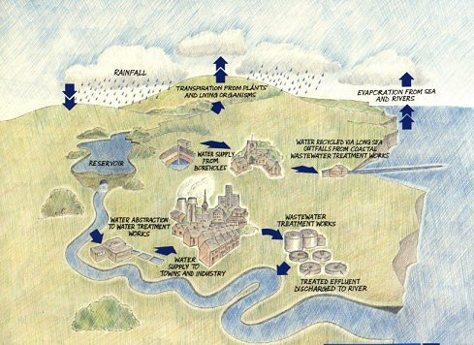
The Water Cycle (human and physical processes)
The Water Cycle
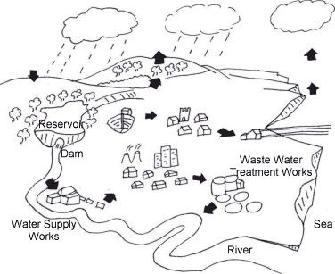
Colour the following:
sea - light blue river and reservoir - dark blue
towns - grey land - green
2) Cut out the following statements and put them in the right place on the diagram.
Water is supplied to towns after it is treated at a Water Supply Works. | Water evaporates from the sea into the atmosphere, as invisible water vapour.
Water is supplied to towns from underground boreholes. | The water vapour rises. As it rises, it cools down to form water droplets. The water droplets condense to form clouds.
Water vapour also enters the atmosphere from transpiration by trees and plants. | Water is pumped from reservoirs into Water Treatment Works so that the water is clean for people to drink.
Dirty water is taken to the Waste Water Works, where it is cleaned. | Water from towns is put back into the sea by long outfall pipes, after being cleaned.
The clouds blow inland. More water droplets gather in the cloud. | Once the water droplets become too big, they fall as rain. The water goes into the river directly, or by trickling through the ground.
At the Waste Water Treatment Works, treated water is put back in the river.

How much water do we use in one day?
Here's how much water you use each time you do one of these things:
 | 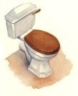 | 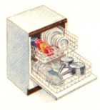
Cooking / drinking: 25 litres | Flushing the toilet: 9 litres | Dishwasher: 50 litres
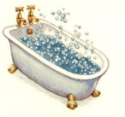 | 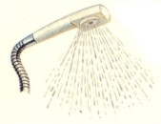 | 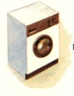
Bath: 80 litres | Shower: 30 litres | Washing machine: 100 litres
Fill in the table below for yourself and the rest of the people in your house for one day.
Activity | Number of times used | Total amount of water used
Cooking / drinking |  | litres
Flushing toilet |  | litres
Dishwasher |  | litres
Bath |  | litres
Shower |  | litres
Washing machine |  | litres
Now work out the total amount of water your house uses in one day by adding up all the numbers in the last column.
Total amount of water = ________ litres
How much water do you think your family would use in a week?

Introducing rivers
1) Write down two things that you know about rivers:
________________________________________________________________
2) Have you ever seen a river before? If so, what was the name of the river?
________________________________________________________________
3) Where is this river found?
________________________________________________________________
4) What was this river like? What colour was the water?
________________________________________________________________
5) Where do you think a river begins?
________________________________________________________________
6) Where do you think a river ends?
________________________________________________________________
7) Do you think rivers look the same from beginning to end?
________________________________________________________________
8) Do you think all the rivers around the world look exactly the same?
________________________________________________________________
9) Suggest ways in which rivers might be different from one another.
____________________________ ______________________________
10) Suggest ways in which rivers are similar.
____________________________ _______________________________
11) What do you think people use rivers for?
________________________________________________________________
12) Why do you think rivers are important to people?
________________________________________________________________

Where is the River Frome and how does it change from source to mouth?

(How does landuse around the river change? Extra teacher only objective)

Starter: The teacher gives pupils three or four grid OS map extracts for the class from a local area. These cover
1. The source of the river near Evershot
2. The river in Dorchester
3. The river near Wool
4. The mouth at Wareham

The pupils are asked:
Where does the river Frome start & finish? Pupils are asked to put the sheets into an order. (Give them some freedom here to come up with ideas and encourage them to sequence them in the best order going from the start to the finish of the river. To help get them to think about the size of the river – it should get bigger as you move downstream)

The aim of this part of the lesson is for the children to explore the extracts and think for themselves. Don’t worry about teaching the children about the river features, we will fill their minds with the details later! You can always go back to looking at the extracts again once the features have been studied.

Development activity:
1. Next pupils are asked to pick out some of the features found at each of the extracts and pick out how the land is used around the river in each of the squares. See resource sheet. Give each pair a copy of the Ordnance Survey symbols to refer to.

The teacher asks pupils to spot any changes as you move downstream

2. Finally, pupils are asked to compare an OS map extract and an aerial photo showing the mouth of the River Frome at Wareham. They list differences and then answer the questions below. There is no right or wrong answer to which source is better – each is better in different ways!

Plenary:
Which part of the River Frome that you have looked at today would you most like to visit and why?
Use a few minutes to discuss your ideas and then share your ideas with the class!

How does land around the River Frome change as you move downstream?

Map extracts | Size and appearance of the river | Natural and human landuses | Nearby settlements
Grexy Cross, Near Evershot

Dorchester

Wool

Wareham

Things to think about as you complete this table

Size and appearance of river – How much space in the grid square does the river take up? Most of the square/ Some of the square / very little of the square. Is it bigger than the river in the previous extract?

Extension: The side of one grid square is 1km – can you work out the width of the river using this scale?

Natural/ human landuses – use the key to decide how the land is being used either side of the river (remember natural = made by nature, human = made by people)

Nearby settlements – What do you find nearby? Are there villages, towns or farmhouses? Try to name some from the map.

Comparing Ordnance Survey (OS) Map extracts and Aerial Photographs

List your ideas!

What information can you get from the OS map extract of the River Frome at Wareham?  Use the key to help you! | What information can you get from an aerial view of the River Frome at Wareham?

Which is most useful for finding where the Information Centre is in the area?

Which would you use to see how farmers are using the land?

Which would you use to decide where to build new houses?

Which is best for telling you where the river floods?

Which resource is best for finding out about the River Frome at Wareham and its surrounding area?

Extra information about the general course of a river (downloaded from www.kented.org.uk )
All rivers start at the highest point in an area. As the river flows downstream, it gains more water from other streams, rivers, springs, added rainfall, and other water sources.
What is a river?
A river is fresh water flowing across the surface of the land, usually to the sea. It flows in a channel. The bottom of the channel is called the bed and the sides of the channel are called the banks.
Where do rivers begin and end?
Rivers begin at their source in higher ground such as mountains or hills, where rain water or melting snow collects and forms tiny streams called gullies.
Gullies either grow larger when they collect more water and become streams themselves or meet streams and add to the water already in the stream.
Find out more about the different sources of rivers.
The great majority of rivers eventually discharge into either the sea or a lake.
How are rivers formed?
When one stream meets another and they merge together, the smaller stream is known as a tributary. It takes many tributary streams to form a river.
Source
The source is the start, or beginning, of a river. The source of a river is usually found in the hills or mountains. A river can have more than one source. The source is where a river begins its journey.
Types of source
There are many different ways in which rivers can begin:
Springs. Some rivers begin where water flows out of rocks. Rainwater sinks through the soil and trickles through the cracks and spaces in rocks such as chalk and limestone. These are called permeable rocks. The water continues to do this until it reaches a rock like clay. Clay is an impermeable rock.
The water gradually builds up between the boundary of impermeable and permeable rocks. Eventually, it trickles out of the rocks.
Rills and streams. A lot of rain falls on mountains. Rainwater flows down slopes and quickly makes channels. At first the channels are small. They are called rills. These join together to make bigger rills. Finally a stream is formed. The streams join up to make a river.
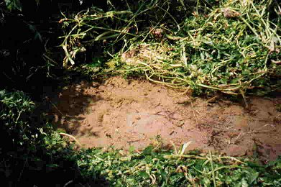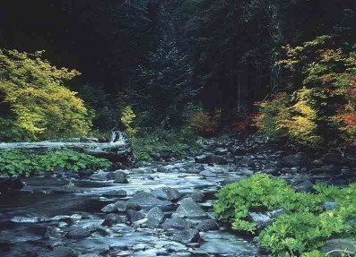
Lakes. The source of some rivers is a lake. The source of the River Nile is Lake Victoria, in Burundi.
Melting snow and ice. Water from a melting glacier may be the source of a river. The snow and ice melt when the weather gets warmer. This forms a lake in front of the glacier. The water rushes into channels in the V-Shaped valley and eventually forms a river.
Bogs. In some places, rain water can't sink into the ground as the ground is too wet already. The water forms a bog. The soil and plants nearby soak up the water. the water flows out of the bog to form lakes and streams.
What are the main features of a river? (At least two lessons)

Possible starter or plenary activities

Starter 1:
Mix and match activity – pupils are asked to link the picture to the correct key term/ feature – Key Terms: Source, Mouth, Meander, Waterfall

These photos can be printed out or incorporated in a PowerPoint presentation

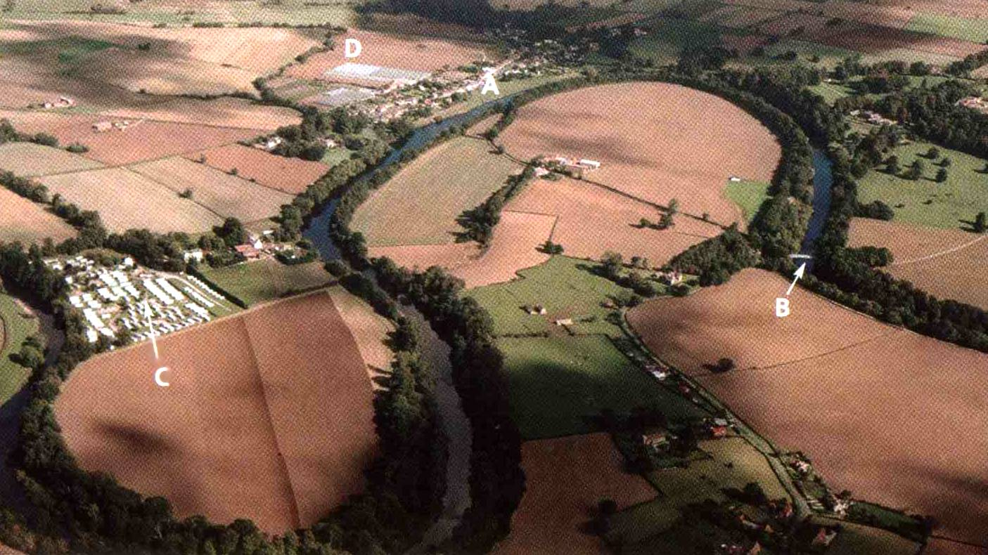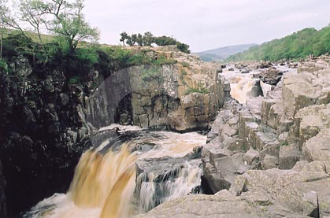

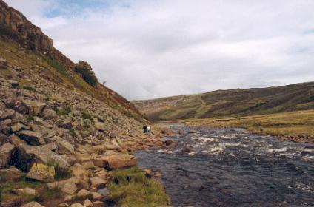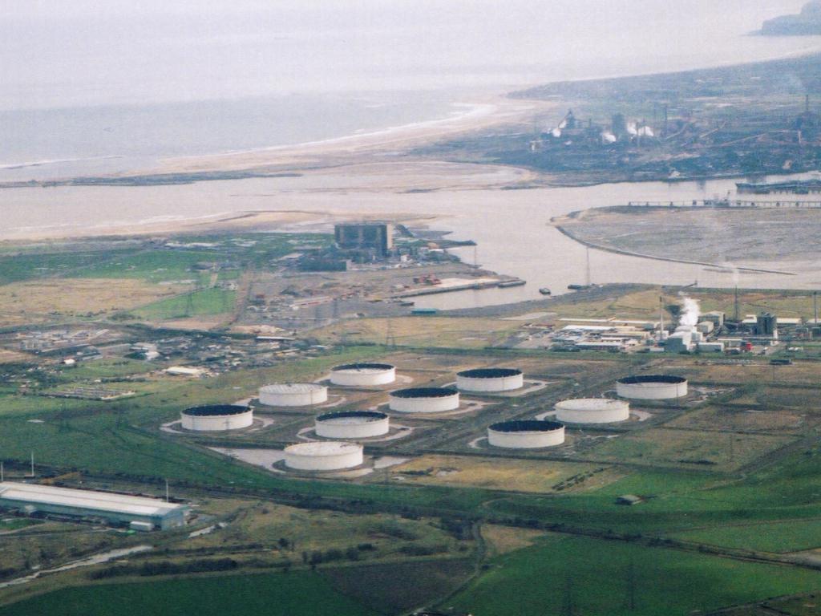

Starter 2:

Give each child an enlarged card from the Rivers Snap pack. Pick a child and the children with the other two cards come to the front. There should be a rivers keyword, a definition and a picture for each keyword.

Or
Give pairs of children the smaller Rivers Snap cards for them to sort themselves. You could use the keyword definitions for the more able

Plenary 1:

Pupils return to looking at the aerial extract for the River Frome at Wareham – the teacher asks the class to pick out using the right key words at least three river features shown in the image.

Plenary 2:

Play Taboo using the definitions on cards
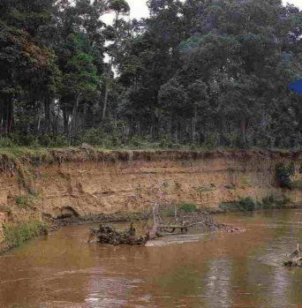

Starter / plenary 3

Put a photo of the river bank on the whiteboard. Ask children what it shows.

It shows an eroded river bank. The clues include:
- exposed tree roots
- cracks in the soil in a river bank
- clumps of grass in the river
- the top part of the river bank overhangs
- brown or coloured water

Possible main activities

Development activity 1A:
Issue each pair of pupils with a numbered card – tell them that the class is going to become a river. They need to sequence themselves into the right numerical order and then read out the cards to tell the story of a river. They could then stick their cards onto the board or a large diagram of a river to show the change that happens as you move downstream.

Card 1  The ground is boggy here and small rivers are forming taking water down hill. The source. | Card 2  Surrounding the river is rough, wet, hilly land – it’s no good for anything here. | Card 3  The small channels meet up and make a slightly bigger river. The water flows fast here. | Card 4  As the river flows fast a valley starts to take shape | Card 5  Soon the river is getting a lot bigger as lots of other small rivers join it. (Tributaries)
Card 6  The land around the river is now changing and instead of empty hills you will start to see sheep grazing. | Card 7  The river starts to change as it moves from hills to flatter land | Card 8  As the river flows over this land it starts to get wider and deeper. | Card 9  The bigger, wider river starts to flow in a winding direction over the land making meanders. | Card 10  As the river meanders you may find towns and cities being built. They grew up in the past to make use of the river.
Card 11  The river now gets very wide and very deep. It is brown because it is full of mud and silt. | Card 12  The river meanders over a flat area of land – a flood plain. | Card 13  Next to the river the floodplain is used for farming and sometimes for factories | Card 14  The river is biggest as it gets near to the mouth. | Card 15  At the mouth the river goes into the sea.

Development activity 1B:
Using the cards (which are now on the board) Imagine you are a jagged pebble that falls into the river at the source. What would happen to you and what would you see as you move downstream?

For less able pupils ask them to draw the river with labels from cards 1, 9, 14 – remember to flesh out their pictures they need to refer to the other cards in the sequence. (Card 2+3 help to draw card 1 etc)

Development activity 2:

Watch the RiverFlight film, which is on the network (see Read AllUsers, Network Delivery Trial, Humanities). There are two parts, each lasting 15 minutes.

The children can take notes on the River Notes sheet, which has all the keywords on it. Some words are repeated because they appear in two different parts of the river, e.g. erosion in the upper course of the river is mainly downward (vertical) and the erosion further downstream is mainly sideways (lateral), usually on the outside bend of a meander.

Development activity 3 (to be attempted after development activities 1 or 2:

Make a River Collage. This can either be done as a whole class display whereby each child contributes to part of the display; or children can produce their own collages either individually in pairs.
First the children to decide which features they will show on their collage. It is a good idea to sketch their river system onto the paper first so that they have some idea of what it will look like. You should encourage the children not to show too many features. They should make a list as well stating which resources they will need to successfully complete their task. If the children know about this task early enough, they can bring in some materials to use from home, e.g. scraps of material and card.
Give the children a piece of A3 (minimum size) paper or card. Explain to the children how to make a collage by building up the layers starting with the big pieces first such as the mountains and then putting on the smaller features. After the children have finished they can produce some word processed labels for their river features and glue them onto their collage
Resources required : A3 size paper or card (minimum size), a variety of colours of tissue paper, crepe paper, coloured paper, cotton wool, and materials to use for the features, scissors, glue

Development activity 4 (to be attempted after development activities 1 or 2):

Fill in one of the river feature worksheets so that the children have the keywords in their exercise books

Development activity 5 (to be attempted after development activities 1 or 2):

Teach children about the formation of waterfalls using one of the websites on Topicbox, the River Book (textbook) or worksheets in the file.

Waterfalls are not included in the RiverFlight video.

Look at the diagram below. It explains how a waterfall is formed.
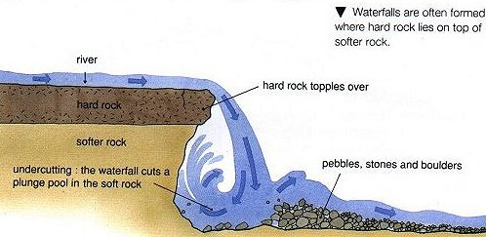
Water from the river flows over the hard rock. Where the water flows over soft rock, it can erode or wear this softer rock away. Over time this soft rock is eroded more and more by the water flowing over it. This makes a cliff which the water topples over. At the bottom of the cliff some of the water splashes onto the cliff and makes a plunge pool by a process known as undercutting. A gorge which is a steep sided river valley is often formed by a waterfall.
Using the diagram above, explain in your own words how a waterfall is formed.

River feature definitions. These correspond to the pictures and keywords in the matching activity.

Meander

This is a bend in a river. These normally occur in the middle and lower courses where the water is moving more slowly. The river carves out S-shaped bends.

Estuary

This part of the river has a mixture of salty and fresh water. The fresh water from the river extends out into the sea. Some of the salty water from the sea travels up the wide river mouth.

Tributary
This is a stream or river flowing into a larger river. The water being drained from two areas now flows in one main channel. A river grows as more of these flow into it.
Waterfall
This feature is formed where water flows over a cliff or very steep drop in the river's bed.
Confluence
This is the point at which a tributary joins a major river.
Mouth
This is where the river stops flowing. Most of these occur where the river meets the sea, but some rivers end their journey in a lake or even in the middle of a desert.
Ox-bow lake
This feature is named after the old fashioned 'U' shaped yoke that was once used to hitch an ox to a plough. It is formed when a river breaks through the neck of a meander, leaving part of the river cut off from the rest.
Source
This is where a river begins its journey and it is usually found in the hills or mountains.
Delta
This feature only occurs when rivers move slowly at the river mouth. The river deposits (drops) its sediment and mud at its mouth which spread out into a fan- like shape across the mouth of the river.
River
This is a natural stream of water, which flows in a channel towards a mouth or lake or another river.

River Snap definitions

This is a bend in a river. These normally occur in the middle and lower courses where the water is moving more slowly. The river carves out S-shaped bends. | This part of the river has a mixture of salty and fresh water. The fresh water from the river extends out into the sea. Some of the salty water from the sea travels up the wide river mouth. | This is a stream or river flowing into a larger river. The water being drained from two areas now flows in one main channel. A river grows as more of these flow into it. | This feature is formed where water flows over a cliff or very steep drop in the river's bed.
This is the point at which a tributary joins a major river. | This is where the river stops flowing. Most of these occur where the river meets the sea, but some rivers end their journey in a lake or even in the middle of a desert. | This feature is named after the old fashioned 'U' shaped yoke that was once used to hitch an ox to a plough. It is formed when a river breaks through the neck of a meander, leaving part of the river cut off from the rest. | This is where a river begins its journey and it is usually found in the hills or mountains.
This feature only occurs when rivers move slowly at the river mouth. The river deposits (drops) its sediment and mud at its mouth, which spread out into a fan- like shape across the mouth of the river. | This is a natural stream of water, which flows in a channel towards a mouth or lake or another river.

River Feature Taboo Game

On each card there is a rivers keyword in bold. One child has to define that word so that their team can guess it, but they may not use any other word on the card. They may not use hand gestures, but can use words that are unrelated, e.g. ketchup for source etc

One idea is to split the class in half and choose one child from the first team to come to the front. They will then have one minute to define that first word on the card until that half of the class guess it correctly. They can pass, but only twice during their go. If they use any of the words on their card, they have to go on to the next card. If their word is guessed correctly, they earn a point for their team and they can go on to another card. After one minute, the next team have a go. You could use two sets of cards, one for each team, so that words can be repeated.

Another idea is to play in small groups and let pairs of children define the words to the other members of the group.

Please edit the cards if necessary, or omit some of them if you think that they are too tricky.

I have highlighted the most useful words in blue.
river |  | deposition |  | source
flow  water |  | drops  beach |  | start  beginning
flood |  | estuary |  | spring
overflow  burst |  | end  tides |  | start  Boing!
tributary |  | fertile |  | confluence
meet  join |  | good  crops |  | meet  join
silt |  | mouth |  | meander
sand  mud |  | end  sea |  | curve  bend

valley |  | delta |  | erosion
sides  V shaped |  | triangle  Nile |  | wears away  bank
waterfall |  | reservoir |  | sea
drops  fall |  | lake  storage |  | ocean  salty
stream |  | rapids |  | Middle course
small  river |  | rocky  rafting |  | between  course
Lower course |  | Upper course |  | gorge
end  course |  | first  course |  | steep  canyon

Upper course Middle course Lower course
Rivers notes

Notes from River Flight film

Source

Spring
Mountains
Stream
Channel
Erosion
Waterfalls and rapids
River basin / drainage basin / catchment area
V shaped valley
Confluence
Tributary
Flood plain
Deposition
Sandbanks
Fertile soil
Meanders
Erosion
Deposition
Ox-bow lakes
Tidal
Estuary

Mouth
Remember that….
Rivers flow downhill due to gravity
The river channel widens and becomes shallower closer to its mouth
The river valley widens and flattens as the river flows downstream
The speed of the river decreases as the slope decreases
The river load can contain rocks, pebbles, gravel, sand, silt and mud
Sea

Delta
Why do people choose to live near rivers?
How does the use of rivers change in different countries?

Starter:
Pupils are asked to answer a series of questions presented in a quick slide show where they see pictures of landuse near rivers at a number of points along a river. (See PowerPoint – Why do people live near rivers?)
They need to come up with a list of reasons why people might choose to live near a river. The last slide points out the possible pitfalls of living near a river.

Development activities:
Pupils compare two images: one showing family life alongside a river in India and another along the Thames in London. The pupils are asked to imagine they could ‘step into’ the picture and are then asked to write a piece of ‘mood’ writing describing the following for each image
- The sights
- The smells
- The sounds
- The activities

See images on the next pages. Please choose two contrasting pictures (or find some better ones!) and either print out one of each per pair or display on the whiteboard.

Development activities 2:
Pupils are asked to then compare the two places by writing some complex sentences that include comparative connectives.
For example:
In India the river is important for people to wash in whereas in London the Thames has been used for people to go sightseeing along.
In India many families have to use the river to wash clothes in, unlike in London where people choose to visit the river for a nice walk.

Plenary;
Pupils share their sentences with the class.
Ask where they would choose to live out of the two places. Give reasons.

What might these two river scenes be like in a hundred years time? (Contrast with the changes in and around the River Thames in Victorian times)
(Use a Victorian picture of the Thames)
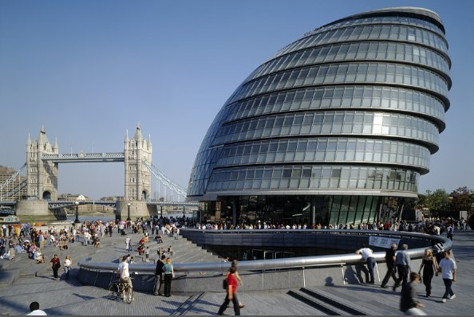

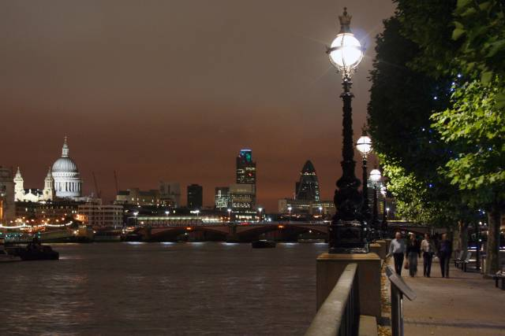
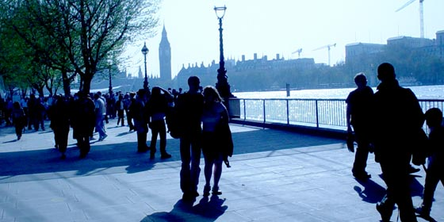

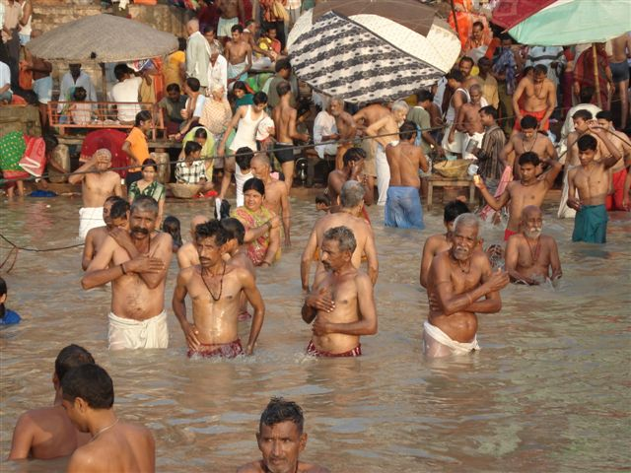
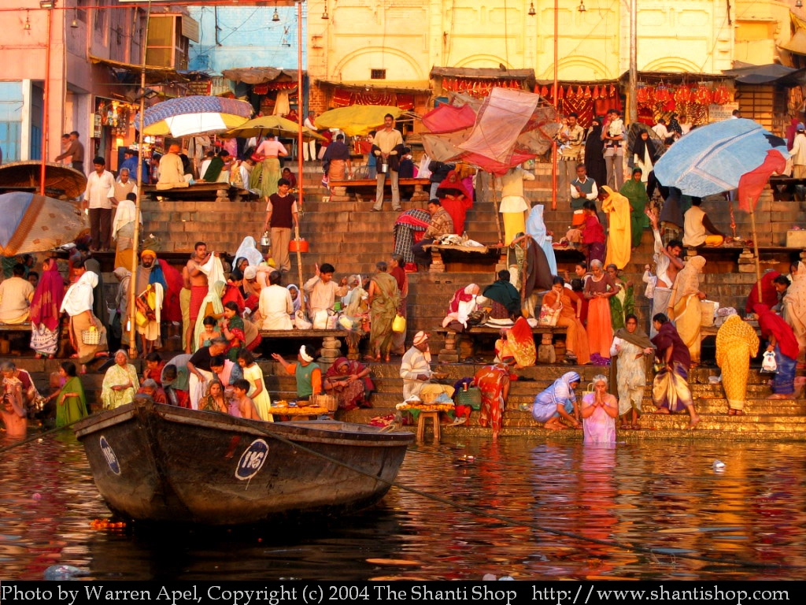
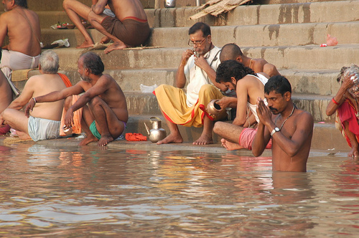
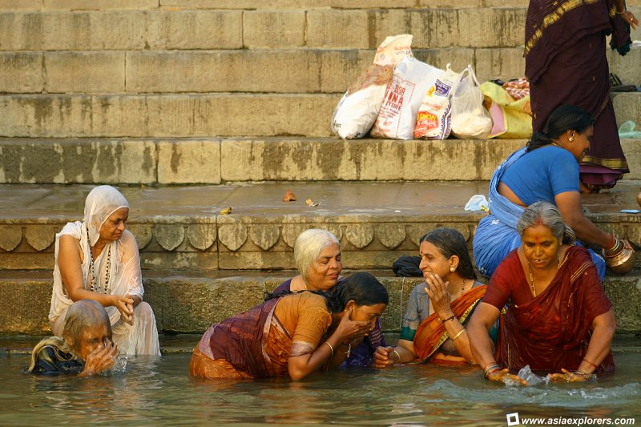
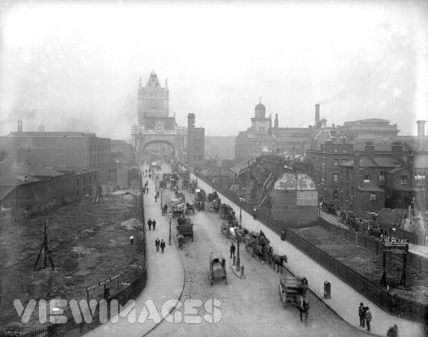

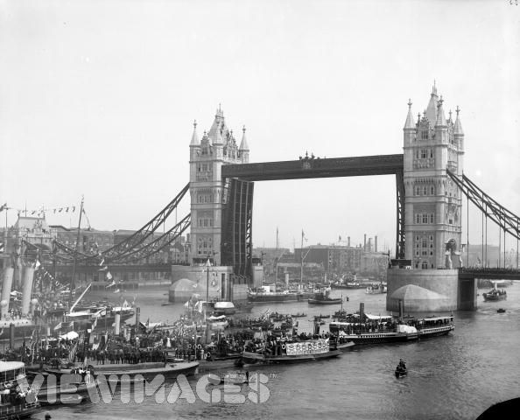

What are the advantages and disadvantages of the Three Gorges Dam?

Starter:
Introduce to the pupils the Three Gorges Dam project in China. Watch the four-minute movie on http://www.geographyatthemovies.co.uk/Rivers.html (but turn the sound down as there is only a backing track which is not entirely suitable)

There is also a PowerPoint presentation called ‘Three Gorges’ that could be used instead, or in addition to, the ‘movie’.

Using the slide show explain what the dam project is and encourage pupils to pick out key details in the images – to help the discussion ask them ‘What can you see in the pictures that make this project special?’

Development activity
Pupils complete a card sort activity where they decide the advantages and disadvantages of the Three Gorges – ideally they might even see that there are some cards that could be both

Development activity
Pupils need to complete a set of speeches for a selection of interest groups. Pupils work in table groups to come up with a speech for one of these groups.

Pupils present their speech to the rest of the class.

I used to live near the Yangtze river where I worked as a fisherman… | I work for the Chinese Government and it is my job to make sure that the dam is finished on time…
I am a skilled construction worker and I think that the three Gorges Dam project… | I have just found out that my family is going to have to leave our village…

Plenary;
They then split up into rainbow/ jigsaw groups and have a group discussion to decide who the biggest winners and losers are from the Three Gorges project.

Sort into positive benefits and negative effects

The dam produces the equivalent electricity of eighteen nuclear power plants | The wildlife and ecology of the river has been affected by the dam | The Chinese are very proud to have the largest dam in the world
There are dangers of landslides | The stored water allows more land to be irrigated so more crops can be grown | More that 1200 villages and towns were destroyed
Fish numbers are diminishing because artificial fertilisers run off the land and into the river and lake and poison the fish | Many archaeological sights were moved or lost under the water | Floods no longer threaten the towns and villages
The dam stopped the seasonal flooding and so the fertile silt deposits stopped. Farmers now have to buy expensive fertilisers to help their crops grow. | Electricity is cheap and renewable, therefore it is an environmentally friendly way to produce power | Large-scale heavy industry has grown up around the dam
There is a risk the dam could be bombed | There is a danger of an earthquake because of the great weight of water. | The project will allow 10 000 ton ships to travel easily into the centre of China
Over two million people have been relocated | The Three Gorges Dam Project will attract tourists to the area. | Three Gorges Dam Project will protect 1,533,333 hectares of farmland, and the lives of 15 million people and their property.

How do people use and misuse rivers? (probably two lessons)

Starter: Ask the children if they have visited a river before. What did they do there? (How did they ‘use’ the river?) e.g. fishing, boat trips, walking. These are known as recreational or leisure uses. Show pictures on the worksheet following this plan.

Who might use the rivers for business or industrial reasons? (factories and power stations use water for cooling, farmers use river water to irrigate their crops, in the past rivers were used to power water mills, sewage works put treated water back into rivers). Show pictures on the worksheet following this plan.

Development activity 1- River uses :
Children could produce spider diagrams showing the different ways that rivers are used. They could put some of these ideas into a poster to encourage visitors to a river area (possibly an area that they are familiar with)

Starter 2 / Development activity 2 :
Play the River Game in groups of 3 or 4.The game revises some of the river features and mentions the different uses of the river, and the possible causes of pollution.

Development activity 3 – River pollution :
Unfortunately sometimes people misuse rivers and damage them. Explain that many towns and factories are built by rivers and they use the water from the river. When the water is pit back into the river it is often dirty or polluted with rubbish, chemicals and other waste products. Farmers can put chemicals and waste products on their land, which can end up draining into rivers. We can also pollute rivers by putting chemicals down the sink and toilets.
Use the types of pollution worksheet and other worksheets or photographs to examine the types of pollution. (I have a Big book that has some drawings of pollution problems)
In their humanities books the children could note down the causes and effects of water pollution as well as solutions to the problems. This could be displayed as a flow diagram.
Types and causes of water pollution
Farmers spray fertilisers on to their fields to make crops grow better.
Solutions to water pollution : prevention; and the ways water pollution can be cleaned up.
Farmers could stop using fertilisers or they could only use them away from the rivers.
Some chemicals drain into the river and kill the fish and make plants grow too quickly
The effects of water pollution

Plenary:
What can you do to stop our rivers from becoming polluted? (take care when disposing of waste, buy environmentally friendly cleaning products, write to newspapers or council etc…)

Recreational uses of rivers and reservoirs
Look at the photos and captions below. The photos show some ways in which a river and reservoir can be used. Match the captions to the photos. Cut them out and paste them in your book.
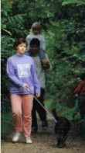 | 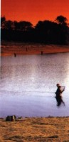 | 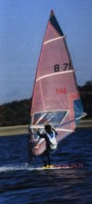
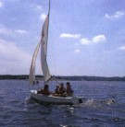 | 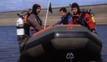 | 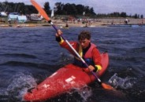
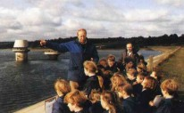 | 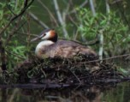 | 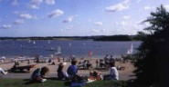

School visits | Having a day out | Bird watching
Walking a dog | Diving | Fishing
Wind surfing | Canoeing | Sailing
Think of some other ways in which rivers and reservoirs can be used for recreational purposes.

Industrial and domestic uses of water
Cut out the pictures. Decide whether they show water being used for domestic, industrial or agricultural purposes. Cut out the labels and match to the pictures.
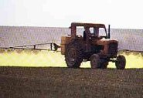 | 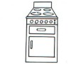 | 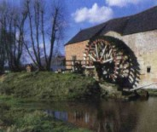
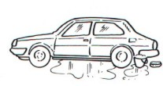 | 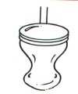 | 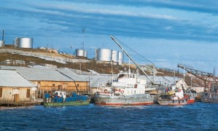
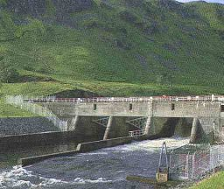 | 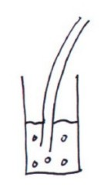 | 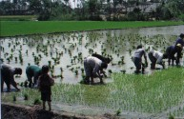
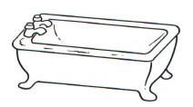 | 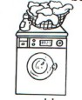 | 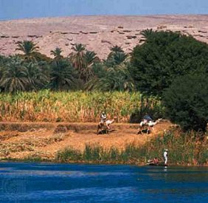

Bath | Washing a car | Water used in factories | Crops by the Nile
Toilet | Water mill | Dam making hydro-electric power | Cooking
Spraying Crops | Drinking | Washing machine | Rice Farming
Types of pollution
Look at the pictures and statements below. They show all the different types of pollution from factories, farming and people's homes. Match the statements to the correct pictures.
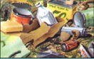 | 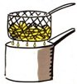 | 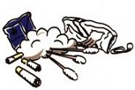 | 
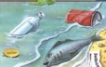 | 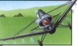 | 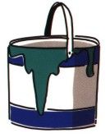 | 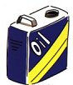
 |  | 

Rubbish thrown into the water | Pollution from household cleaning fluids poured down the sink
Farmers spray chemicals onto their crops to make them grow better. Some of the chemicals drain into the river. | Solid rubbish is often dumped into large holes in the ground. When this rubbish decays, harmful chemicals leak into the ground and into rivers.
Solid rubbish like newspapers and cigarettes dumped into rivers. | Oil pollution from factories
People put weed killer on their lawns. Some drains away into rivers | Pollution from cooking oil
Old medicines and pills | Pollution from paint

