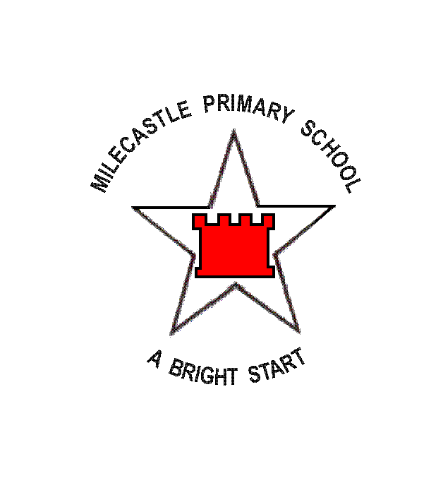

Literacy Unit Plan

Year Group: 6 | Class(es): 13 & 14 |  | Teacher(s): Elaine & Amanda | Term: Autumn 1 | Date: 10-09-07
Literacy Unit:  Narrative Unit 1  Main Focus: Mystery stories |  | Texts:  Extracts from Fingers on the Back of the Neck and other short stories.  Pelican Interactive Big Books  Ghost Story (short film) |  | Outcomes:  Children can identify and discuss the principal features of different genres of children's fiction.  Children can explain reading preferences in terms of the different genres.  Children can analyse the language and organisational features of fiction genres.  Children can plan, draft, write and improve an engaging short story in a particular genre using appropriate language and organisational features.

Whole Class Work | Whole Class Work | Independent / guided work | Plenary
Revise word classes from Y5. Focus on adverbs. | What do we know about the word ‘suspense?’ Ask children to think of stories and films which make us feel tense. Why do we feel like this? Read the 2 story openers from ‘Fingers’ (SMARTboard.) Highlight the things that build up suspense. | Read opening extract from ‘The Hand’ exemplar in pairs and highlight the features that build up suspense.  MA pupils also highlight The Body (from Pie Corbett KS2 English Fiction Purple book) | Think of an opening sentence to use in a suspense story with a partner.
Discuss importance of creating suspense immediately in scary/suspense stories. Read openers again and talk about important features of story openers: dialogue, something strange or intriguing, asking the reader a question. Introducing characters also an important feature of openers. Read build up. Discuss techniques for creating atmosphere and describing setting.  Examine a description of a setting. (Pelican Interactive Book B – How to Write Better Stories – Tutorials and Activities – Sentence Level Activity.) Change short sentences into longer, flowing sentences. Correct punctuation. Refer to VCOP. |  | Text analysis – looking for evidence of suspense in The Hand and The Body | Create menu so far of features that should appear in suspense/mystery stories.  Homework – KB worksheet – how does Charles Dickens build up suspense in Oliver Twist extract?
Connectives – exploring impact of different connectives and use of connectives at the beginning of sentences. | Introduce further 2 sections to suspense stories: dilemma and events and read checklist of features included. Further read sections of short stories and identify techniques used by authors. | HA Gps Key Comprehension Unit 13  LA Gps Letts Key Unit 2 Comprehension | Read dilemma and events section of the hand – ask children to find examples of appropriate features and highlight.
Introduce the final strand of a suspense story – the resolution. Ask children to predict how the shared reading stories will end. Read ending of Ghost Story and identify features of this section for the menu/checklist. Talk about the possibility of ‘Scooby Doo’ endings – a human and normal explanation for the weird events. (longer plenary) |  | In pairs, predict and write the ending of Fingers Down the Back of the Neck, using some of the features identified; either a real ghost or a Scooby Doo ending. | Read the ending of ‘Fingers.’
Openers in descriptive sentences. Flash up an opener and picture of a scary scene on IWB. Ask pairs to write a sentence describing that scene, making it as eerie as possible. | Discuss stories read so far this week and how an element of suspense has been created. Create a menu for mystery/scary genre. | 2007 SAT paper – talk through planning process with pupils for 10 minutes then allow 20 minutes independent writing. Use candle & music as if BIG writing and write in BIG writing portfolios.
Recap menu and features. Listen to music from Ghost Story and ask children to identify what is happening. at different points. Watch the video and explain that we are going to use it as the basis for a story. We need to create a plan which includes information about the character and how he came to be in this situation. Plan the W. |  | Children plan their version. SEN and LA using a scaffold ladder and some suggestion cards to help them.  Guided: Writing: planning effectively; using cohesion in writing through linking the beginning and end of stories e.g. through common events. | Share ideas generated and plans. Encourage pupils to indicate through pictures where they could use the senses hand, exclamations, good vocabulary and intriguing questions.
Remind children of techniques used in stories we read for the opening/introduction of character section. Model writing own opening; pairs to contribute focusing particularly on sentence openers |  | Write 1st of 5 stages in suspense story. Encourage use of different connectives and punctuation of sentences. All using writing frame (inc Guided group) | Read a partner’s work. Tell them 2 things you liked (2 stars)
Remind children of techniques used in stories we read for the build up and dilemma. Model writing own mid sections, asking children to contribute to ideas for use of senses hand and short sentences. Remind children to stop as the man opens the door.  Use 2 examples of sentences from shared writing. Experiment with changing connective – how does it alter meaning? |  | Write sections 2 & 3 sections of ghost story and check for features as in whole class session.  Guided Writing: Use marked written work from yesterday as a starting point for corrections / guiding the group. Use some examples of good writing and show how they can be improved. Support individuals. | Use one child’s story from GW and check for features. Improve 2 sentences using VCOP.
Remind children of techniques used in stories we read for the events and resolution. Model/shared writing own final sections. Discuss option of everything being ‘normal’ having only seemed scary, or finishing with an eerie piece of information. |  | Write final sections of suspense story.  Guided Writing: Use marked written work from yesterday as a starting point for corrections / guiding the group. Use some examples of good writing and show how they can be improved. Support individuals. | Self checking for VCOP and genre features.
BIG Writing:  Assessment of understanding of genre. Give children a checklist of features to enable them to successfully write a scary story. |  | Read opening of story and identify successful features. Take suggestions and give opportunity for paired discussion of ‘what happens next?’ (10 minutes) Allow pupils time to plan on given planning frame and circulate to support(10 minutes) Independent writing (40 minutes)
GUIDED READING  OBJECTIVES:  Identify methods used by author to intrigue reader in suspense stories – locate evidence in text.  Assess individual readers. |  | WORD/SENTENCE LEVEL OBJECTIVES:  - Revise word classes from Year 5  - Use different styles of handwriting for different purposes with a range of media, developing a consistent and personal legible style  - Express subtle distinctions of meaning, including hypothesis, speculation and supposition, by constructing sentences in varied ways  - Use a range of appropriate strategies to edit, proofread and correct spelling in their own work, on paper and on screen  ACTIVITIES:  Week 1  Adverbs (Black P14) change adjectives into adverbs.  Weekly spellings – in sentences & LSCWC  Connectives  Handwriting  Spelling Test  Week 2  Spelling log/editing from independent writing  Weekly spellings – in sentences & LSCWC  Extending sentences – adding clauses worksheet  Handwriting  Spelling test

