 | Autumn 1 | Pos | Autumn 2 | Pos | Spring 1 | Pos | Spring 2 | Pos | Summer 1 | POS | Summer 2 | POS
YR 1 | Unit 1a  Self portrait  (artist – CEZANNE)  www.expo-cezanne.com/1_5.cfm  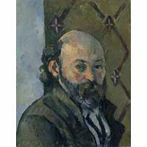 (1839-1906)  Outcome: Self-portrait | 1a, 1b,  2a, 2b 2c  3a, 3b  4a, 4b, 4c  5a, 5b, 5c, 5d | Extendrevisit, other activities |  | Unit 1b – Investigating materials  Janet Bolton  www.janetbolton.com  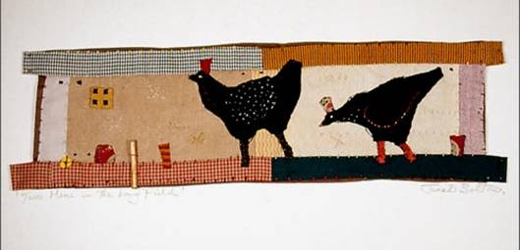  “Two hens in the long field”  Outcome: weaving | 1a, 1b  2a, 2b, 2c,  3a, 3b.  4a, 4b, 4c  5a, 5b, 5c, 5d | Extend, revisit, other activities | 1a, 1b  2a, 2b, 2c,  3a, 3b.  4a, 4b, 4c  5a, 5b, 5c, 5d | Unit 1c – What is sculpture?  http://calder.org/home  Alexander Calder  1898-1976  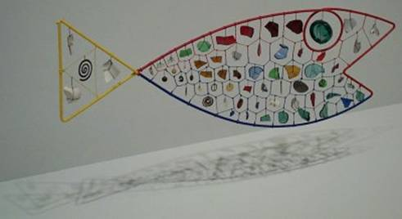  Calder “Fish”  Outcome: Relief Collage/Sculpture | 1a, 1b,  2a, 2b, 2c,  3a, 3b,  4a, 4b, 4c  5a , 5b, 5c 5d | Extend, revisit/ other activities | 1a, 1b,  2a, 2b, 2c,  3a, 3b,  4a, 4b, 4c  5a , 5b, 5c 5d
YR 2 | Unit 2 a – Picture this  Books by  Raymond Biggs or Jill Burton  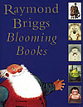  Outcome: photography/collage | 1a, 1b,  2a, 2b, 2c  3a, 3b,  4a, 4b,4b,  5a, 5c, 5d | Extendrevisit, other activities | 1a, 1b,  2a, 2b, 2c  3a, 3b,  4a, 4b,4b,  5a, 5b, 5c, 5d | 2b Mother Nature  www.art.unt.edu/ntieva/artcurr/alsp/matisse.htm  Henri Matisse (1869 – 1954) 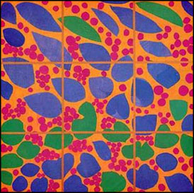  Ivy on flowers 1950  Outcome: observational drawings/collage/appliqué work | 1a, 1b  2a, 2b, 2c  3a, 3b  4a, 4b 4c  5a, 5b, 5c, 5d | Extendrevisit other activities | 1a, 1b  2a, 2b, 2c  3a, 3b  4a, 4b 4c  5a, 5b, 5c, 5d | 2c Can Buildings Speak?  Hundertwasser   www.kunsthauswien.com/english/hundertwasser.htm  Outcome: create a relief panel using diff techniques/materials | 1a, 1b,  2a, 2b, 2c  3a, 3b  4a, 4b, 4c,  5a, 5b, 5c, 5d | Extend, revisit, other activities | 1a, 1b,  2a, 2b, 2c  3a, 3b  4a, 4b, 4c,  5a, 5b, 5c, 5d
Yr 3 | 3a - Portraying Relationships  Antony Van Dyck  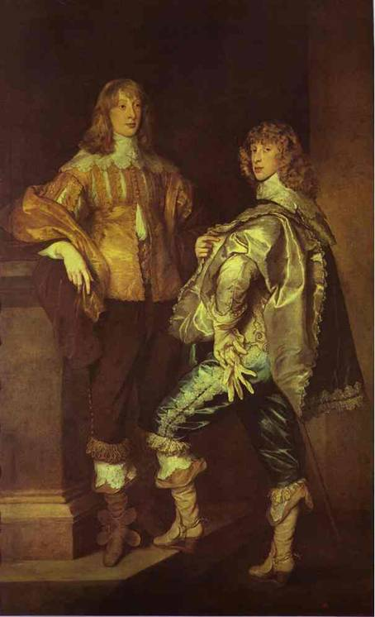  Lord John Stuart and his brother Lord Bernard Stuart", 1638  Outcome: painted composition showing relationship | 1a, 1b,1c  2a, 2b 2c  3a, 3b  4a,4b,4c  5a,5b,5c,5d | Extend/revisit, other activities | 1a, 1b,1c  2a, 2b 2c  3a, 3b  4a,4b,4c  5a,5b,5c,5d | 3b - Investigating Patterns  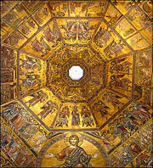  Baptistery, Florence  Roman mosaics  Outcome: make a two-colour printed pattern | 1a, 1b,1c  2a, 2b 2c  3a, 3b  4a,4b,4c  5a,5b,5c,5d | Extendrevisit, other activities | 1a, 1b,1c  2a, 2b 2c  3a, 3b  4a,4b,4c  5a,5b,5c,5d | 3c - Can we change places?  Anthony Gormley    Angel of the North  Outcome: to make a sculpture | 1a, 1b,1c  2a, 2b 2c  3a, 3b  4a,4b,4c  5a,5b,5c,5d | Extend/revisit, other activities | 1a, 1b,1c  2a, 2b 2c  3a, 3b  4a,4b,4c  5a,5b,5c,5d
Yr 4 | 4a –Viewpoints  Marc Chagall 1911  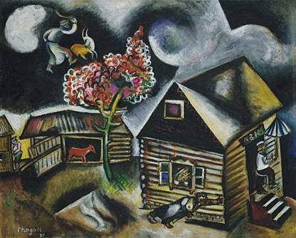  Rain 1911  Outcome: printing | 1a, 1b,1c  2a, 2b 2c  3a, 3b  4a,4b,4c  5a,5b,5c,5d | Extend/revisit other activities | 1a, 1b,1c  2a, 2b 2c  3a, 3b  4a,4b,4c  5a,5b,5c,5d | 4b – Take a Seat  Vincent Van Gogh  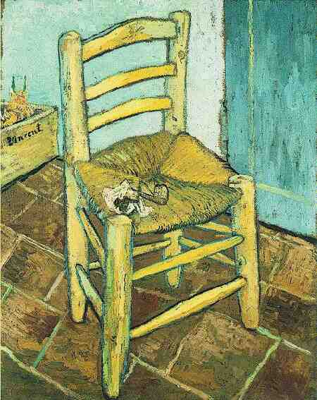  Chair with pipe 1888  Outcome developing their own imaginative designs for a chair | 1a, 1b,1c  2a, 2b 2c  3a, 3b  4a,4b,4c  5a,5b,5c,5d | Extend/revisit other activities | 1a, 1b,1c  2a, 2b 2c  3a, 3b  4a,4b,4c  5a,5b,5c,5d | 4c – Journeys  Kandinsky  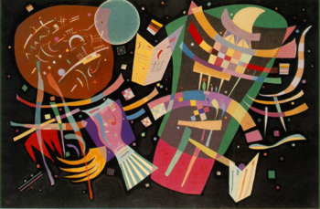  WWII black death  (mixed media)  Outcome: mixed-media work, combining drawing, painting, collage and print-making techniques | 1a, 1b,1c  2a, 2b 2c  3a, 3b  4a,4b,4c  5a,5b,5c,5d | Extend/  revisit, other activities | 1a, 1b,1c  2a, 2b 2c  3a, 3b  4a,4b,4c  5a,5b,5c,5d
UPPER KS2 ART
Yr 5 | 5a Objects and meaning  Picasso  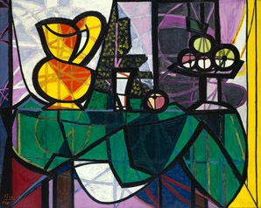  Outcome: still life painting | 1a, 1b,1c  2a, 2b 2c  3a, 3b  4a,4b,4c  5a,5b,5c,5d | Extend/revisitother activities | 1a, 1b,1c  2a, 2b 2c  3a, 3b  4a,4b,4c  5a,5b,5c,5d | 5b Containers  Ed Rossenbach  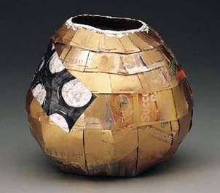  Eskimo pie 1987  Outcome: a three-dimensional form to represent a vessel or container | 1a, 1b,1c  2a, 2b 2c  3a, 3b  4a,4b,4c  5a,5b,5c,5d | Extend/revisit other activities | 1a, 1b,1c  2a, 2b 2c  3a, 3b  4a,4b,4c  5a,5b,5c,5d | 5c Talking Textiles  Arthur Spooner  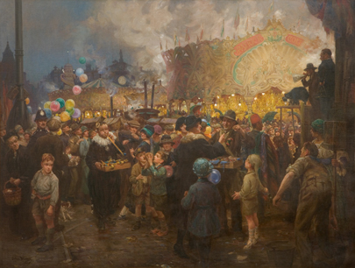  Goose Fair  Outcome: two- or three-dimensional work range of materials, techniques and textile processes to create surface patterns and textures | 1a, 1b,1c  2a, 2b 2c  3a, 3b  4a,4b,4c  5a,5b,5c,5d | Extend/revisit, other activities | 1a, 1b,1c  2a, 2b 2c  3a, 3b  4a,4b,4c  5a,5b,5c,5d
Yr 6 | 6a People in Action  Muyabridge  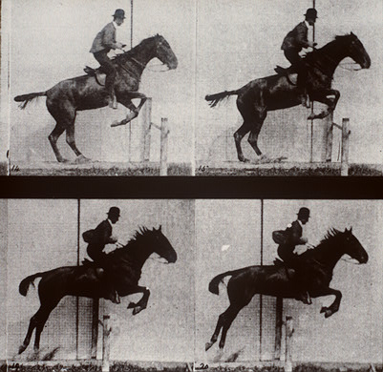  Daisy jumping a hurdle  Outcome: - photography | 1a, 1b,1c  2a, 2b 2c  3a, 3b  4a,4b,4c  5a,5b,5c,5d | Extend/revisit, other activities | 1a, 1b,1c  2a, 2b 2c  3a, 3b  4a,4b,4c  5a,5b,5c,5d | 6b – What a performance  http://www.allposters.com/-st/Leon-Bakst-Posters_c22372_p3_.htm  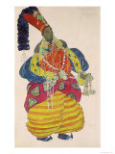  Outcome: designing and making a piece of headwear | 1a, 1b,1c  2a, 2b 2c  3a, 3b  4a,4b,4c  5a,5b,5c,5d | Extend/revisit, other activities | 1a, 1b,1c  2a, 2b 2c  3a, 3b  4a,4b,4c  5a,5b,5c,5d | 6c A sense of place  David Hockney &  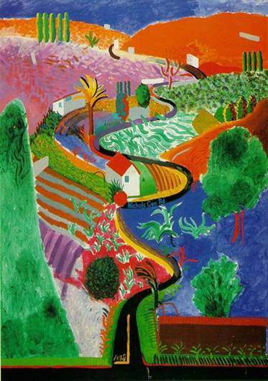  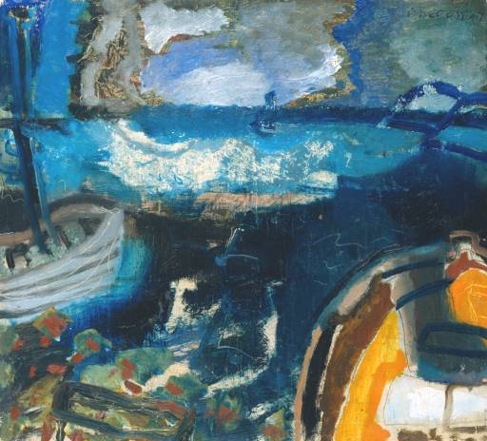  Heron – boats  Outcome: drawing/photography of seascape/landscape | 1a, 1b,1c  2a, 2b 2c  3a, 3b  4a,4b,4c  5a,5b,5c,5d | Extend/revisit, other activities | 1a, 1b,1c  2a, 2b 2c  3a, 3b  4a,4b,4c  5a,5b,5c,5d

 | Autumn 1 | About the Unit/Key Objectives | Spring 1 | About the Unit/Key Objectives | Summer 1 | About the Unit/Key Objectives
Yr 1 | Unit 1a  -  Self portrait  (artist – CEZANNE)  www.expo-cezanne.com/1_5.cfm  (1839-1906)  Outcome: Self-portrait | BOUT THE UNIT  In this unit children make a self-portrait to communicate ideas about themselves. They talk about images of children in drawings, paintings and photographs and artists' self-portraits in order to develop ideas about how they will portray themselves. They investigate a range of drawing materials and techniques and learn how to mix and use colour in a painting.  OBJECTIVES  Section 1: Exploring and developing ideas (1)  Children:  - identify differences in ways that children are represented in art  - identify ways in which artists represent themselves and suggest reasons for this  Section 2: Exploring and developing ideas (2)  Children:  - identify aspects of one self-portrait and say what they think and feel about it  - identify ways in which children in the class are similar to and different from each other  - suggest ideas about how to represent themselves  Section 3: Investigating and making (1)  Children:  - experiment with and use drawing media and techniques to create a range of visual effects  Section 4: Investigating and making (2)  Children:  - record self-portraits from observation, working on different scales  Section 5: Investigating and making (3)  Children:  - comment on differences in others' work  Section 6: Investigating and making (4)  Children:  - plan, compose and make a self-portrait painting  Section 7: Evaluating and developing work (1)  Children:  - use descriptive and expressive vocabulary to talk about their portrait work  Section 8: Evaluating and developing work (2)  Children:  - identify the successful parts of their painting and explain why they think these parts are successful  - identify what they might like to change or improve | Unit 1b – Investigating materials  Janet Bolton  Janet Bolton  www.janetbolton.com  “Two hens in the long field”  Outcome: weaving | ABOUT THE UNIT  In this unit children investigate the qualities of a variety of natural and made materials. They learn skills for weaving and gain sensory experience of materials and an understanding of colour and texture. They learn about how textiles are used in their own and others' lives.  OBJECTIVES  Section 1: Exploring and developing ideas (1)  Children:  - experiment with papers and fabrics and create different effects  Section 2: Exploring and developing ideas (2)  Children:  - identify and describe textures, colours and patterns in textiles  - describe their feelings about a fabric they like  - sort fabrics by colours and textures and describe their ideas and feelings about them  Section 3: Investigating and making  Children:  - investigate the technique of weaving  - use found natural and made materials in weaving, showing understanding of colour and texture  - experiment with cold dyes and water-based paint to develop colour  Section 4: Evaluating and developing work (1)  Children:  - explain how they are making their weaving  - identify parts they like and say what they find interesting about the colour and texture they have created and how it makes them feel  Section 5: Evaluating and developing work (2)  Children:  - identify what they would like to develop in future work | Unit 1c – What is sculpture?  http://calder.org/home  Alexander Calder  1898-1976  Calder “Fish”  Outcome: Relief Collage/Sculpture | ABOUT THE UNIT  In this unit children develop their understanding of shape, form, texture and the sensory qualities of materials. They learn about the work of sculptors and about different kinds of sculpture, including those made of natural materials. They also learn skills for arranging materials they have collected to make a relief collage and a sculpture.  OBJECTIVES  Section 1: Exploring and developing ideas (1)  Children:  - identify the materials used in sculpture  - make comments about the work, showing understanding of why these materials are used  Section 2: Exploring and developing ideas (2)  Children:  - record visual and other information  Section 3: Investigating and making (1)  Children:  - identify colours, textures, smells and sounds in the environment and describe their feelings  - describe differences in surfaces and textures  - recreate natural and made materials into a collage  Section 4: Investigating and making (2)  Children:  - make a sculpture using natural and made materials  - explain how they are making their sculpture  Section 5: Evaluating and developing work (1)  Children:  - identify parts that they like and say what they find interesting about the shapes, forms and textures they have created  Section 6: Evaluating and developing work (2)  Children:  - identify what they would like to develop in future work

 | Autumn 1 | About the Unit/Key Objectives | Spring 1 | About the Unit/Key Objectives | Summer 1 | About the Unit/Key Objectives
YR 2 | Unit 2a – Picture This!  Books by  Raymond Biggs or Jill Burton  Outcome: photography/collage | ABOUT THE UNIT  In this unit children explore an issue or event in their lives. They learn how to use a viewfinder and record their observations and ideas using a variety of methods, including photography and collage. They look at and comment on the work of photographers and illustrators.  OBJECTIVES  Section 1: Exploring and developing ideas (1)  Children:  - frame and record an interesting viewpoint in a drawing and a photograph  - identify similarities and differences between the drawing and the photograph  Section 2: Exploring and developing ideas (2)  Children:  - comment on differences in the messages given by part of an image compared with messages from the whole image  Section 3: Exploring and developing ideas (3)  Children:  - visualise the whole of an image from a given part  - make drawings and paintings using the visual clues from given images  Section 4: Investigating and making (1)  Children:  - create a storyboard for an event or an issue in their lives  Section 5: Investigating and making (2)  Children:  - record a key moment from their story in a photograph  Section 6: Evaluating and developing work  Children:  - identify what they wanted to show in their work and why  - explain how they created certain effects  - identify what might change in their current work or what they might develop in future work | Unit 2b – Mother Nature Designer!  www.art.unt.edu/ntieva/artcurr/alsp/matisse.htm  Henri Matisse (1869 – 1954)  Ivy on flowers 1950  Outcome: observational drawings/collage/appliqué work | ABOUT THE UNIT  In this unit children explore line, shape, colour and texture in natural forms. They make observations of natural objects and use their observations as the basis for textile design. They use their experience of fabrics to make a collage and learn and use simple techniques for applique.  OBJECTIVES  Section 1: Exploring and developing ideas  Children:  - collect and group natural objects and make a visually attractive display  - identify visual and tactile qualities that appeal to them, select a viewpoint and say why they find it interesting  - say what they think they will show in their designs  Section 2: Investigating and making  Children:  - record observations of line, shape, colour and texture  - experiment with fabrics, threads and other materials to create a fabric collage  - use a range of techniques in their work  Section 3: Evaluating and developing work  Children:  - describe the visual qualities of their work  - explain how they created certain effects  - identify what they might change in their current work or develop in future work  - comment on differences in designs | Unit 2c – Can Buildings Talk?  Hundertwasser  www.kunsthauswien.com/english/hundertwasser.htm  Outcome: create a relief panel using diff techniques/materials | ABOUT THE UNIT  In this unit children explore shape and pattern in buildings. They begin by producing prints and rubbings of patterns found in buildings and go on to look at, and record, the use of shape, space and pattern in local buildings. They question how these features tell us something about the purpose of the building. They work in groups to produce a relief sculpture for temporary display, using their first-hand observations as a starting point.  OBJECTIVES  Section 1: Exploring and developing ideas (1)  Children:  - print shapes and patterns  - explain what surfaces their prints and patterns might represent  Section 2: Exploring and developing ideas (2)  Children:  - identify differences in shapes, patterns and decoration in buildings and relate these to the purpose of the building  - record in words and drawings information about a building in the local area  - describe how the inside and outside of the building made them feel  Section 3: Exploring and developing ideas (3)  Children:  - describe and record the visual qualities of shape, pattern and decoration they can see and remember  Section 4: Exploring and developing ideas (4)  Children:  - share ideas about how a large-scale work might look  - use their observations and experiences of local buildings to help them design a panel that emphasises shape, pattern and decoration  Section 5: Investigating and making  Children:  - work collaboratively to create a relief panel by exploring and using a variety of materials and techniques  - discuss and agree how the work will be displayed  Section 6: Evaluating and developing work  Children:  - identify successes and suggest improvements

 | Autumn 1 | About the Unit/Key Objectives | Spring 1 | About the Unit/Key Objectives | Summer 1 | About the Unit/Key Objectives
YR 3 | Unit 3a Portraying Relationships  Antony Van Dyck  Lord John Stuart and his brother Lord Bernard Stuart", 1638  Outcome: painted composition showing relationship between 2 figures | ABOUT THE UNIT  In this unit children investigate how paintings, prints, photographs and other images that include figures communicate ideas about relationships. They use composition skills to make a double portrait that conveys ideas about themselves and their relationship with another person in their lives.  OBJECTIVES  Section 1: Exploring and developing ideas (1)  Children:  - compare and comment on different ideas, methods and approaches to group portrait work  - suggest ideas about why the images were made and what they show about the people in them  - say what they think and feel about the images  Section 2: Exploring and developing ideas (2)  Children:  - record first-hand observations of figures in different poses  Section 3: Investigating and making  Children:  - make a composition showing the relationship between the two figures  - explore how paint can be applied to represent the qualities of the people and objects  Section 4: Evaluating and developing work (1)  Children:  - identify what is most effective in their own and others' work and suggest improvements  Section 5: Evaluating and developing work (2)  Children:  - compare and comment on their own and others' portrait work  Section 6: Evaluating and developing work (3)  Children:  - create a collaborative picture combining a number of figures in a group composition  - work in a group to agree a plan for their composition  - organise and combine shapes, colours, patterns and textures, using mixed media | Unit 3b – Investi-  gating Patterns  Baptistery, Florence  Roman mosaics  Outcome: make a two-colour printed pattern | ABOUT THE UNIT  In this unit children investigate patterns in textiles from different times and cultures. They use ideas from these as a starting point for developing their own designs. They investigate stencilling and print-making techniques and explore ways of combining and organising shapes, colours and patterns to make a decorative textile piece.  OBJECTIVES  Section 1: Exploring and developing ideas (1)  Children:  - identify simple shapes and those based on animals, plant forms or other objects  - describe different ways that patterns are made  - identify materials and techniques and how these are used in patterns  Section 2: Exploring and developing ideas (2)  Children:  - explore ways of making and creating their own patterns  Section 3: Investigating and making (1)  Children:  - experiment with stencilling and block-printing techniques  - consider the development of their work at each stage  Section 4: Investigating and making (2)  Children:  - make a two-colour printed pattern  Section 5: Evaluating and developing work  Children:  - identify the similarities and differences between their own and other children's work  - suggest different purposes for their work and where it might be used | Unit 3c Can we change places  Anthony Gormley  Angel of the North  Outcome: to make a sculpture | ABOUT THE UNIT  In this unit children explore sculpture in public buildings and spaces. They explore and use shape, form, colour and pattern to make a maquette or model of a sculpture for a site in the school or the local area. They compare the ideas, methods and approaches used in the work of different sculptors. (examples of the work of sculptors who use 'found' materials in their work, eg Picasso, Louise Nevelson, Tony Cragg photographs of sculpture in the environment, eg 'Angel of the North' by Antony Gormley.  OBJECTIVES  Section 1: Exploring and developing ideas (1)  Children:  - identify ways in which the environment influences our lives and how we feel  - suggest how art has been used to improve a place  Section 2: Exploring and developing ideas (2)  Children:  - build up a portfolio or sketchbook of visual and other information  Section 3: Exploring and developing ideas (3)  Children:  - develop their ideas for a sculpture for the chosen site  Section 4: Investigating and making (1)  Children:  - explore the visual and tactile qualities of found materials and objects  - experiment with and make imaginative use of materials and objects  Section 5: Investigating and making (2)  Children:  - investigate and use appropriate ways of fixing and joining to create an assemblage that suits their intention  Section 6: Evaluating and developing work  Children:  - compare and comment on their own and others' work  - take account of others' views to help them improve their work
 | Autumn 1 | About the Unit/Key Objectives | Spring 1 | About the Unit/Key Objectives | Summer 1 | About the Unit/Key Objectives
YR 4 | Unit 4a Viewpoints  Marc Chagall 1911  Rain 1911  Outcome: printing | ABOUT THE UNIT  In this unit children explore how to convey the atmosphere and story of a dream. They explore different viewpoints in the school environment as a setting for their dream. They invent a number of characters who are photographed 'on location' and develop a narrative to describe the dream. They go on to make prints based on the narrative. They compare the ideas, methods and approaches used in their own and other artists' and print makers' work.Suggested examples of art, craft and design photographs and film sequences showing ways of conveying drama, build up of emotion or tension.  OBJECTIVES  Section 1: Exploring and developing ideas (1)  Children:  - compare and comment on how visual and other effects are used to convey ideas and feelings in moving images  - record ideas about their own experiences in different ways  Section 2: Exploring and developing ideas (2)  Children:  - record observations and ideas about the built environment  Section 3: Exploring and developing ideas (3)  Children:  - make an annotated visual plan for their work  Section 4: Investigating and making (1)  Children:  - experiment with photographic or film-making techniques to suit their intentions  Section 5: Investigating and making (2)  Children:  - select one image and develop a design for a print  - make a series of prints, exploring overprinting and colour combinations  Section 6: Evaluating and developing work  Children:  - modify and improve their designs using what they have learnt from the study of other artists  - modify and improve their prints by acquiring technical control and using this to produce visually interesting images | Unit 4b – Take a Seat  Vincent Van Gogh  Chair with pipe 1888  Outcome developing their own imaginative designs for a chair | ABOUT THE UNIT  In this unit children explore the design of chairs. They discuss what chairs tell us about everyday life and the way people rest, eat and relate to each other. They look at examples of designs in the past and in other cultures as inspiration for developing their own imaginative designs for a chair for a particular character or occasion.  OBJECTIVES  Section 1: Exploring and developing ideas (1)  Children:  - identify the parts of the chair and their purposes  - identify different types of chair and the materials used  - comment on how the form of chairs is related to the purposes  - comment on how materials are used in making chairs  Section 2: Exploring and developing ideas (2)  Children:  - explore ideas for a design to represent a character or event  Section 3: Exploring and developing ideas (3)  Children:  - record and collect visual and other information to inform their ideas for designs  - adapt and improve their sketchbook work  Section 4: Investigating and making (1)  Children:  - use their sketchbook drawings to inform their design either to construct a scale model of a chair to represent their chosen character or event, or adapt and decorate a chair to represent their chosen character or event  Section 5: Investigating and making (2)  Children:  - make decisions about how the chair is decorated to reflect their chosen character  Section 6: Evaluating and developing work  Children:  - identify the success of the design and what they think is interesting about it | Unit 4c – Journeys  Kandinsky  WWII black death  (mixed media)  Outcome: mixed-media work, combining drawing, painting, collage and print-making techniques | ABOUT THE UNIT  In this unit children explore how signs, symbols and metaphors can be used to communicate ideas and meanings about a journey. They produce a mixed-media work, combining drawing, painting, collage and print-making techniques. They learn about artists, craftspeople and designers who communicate their ideas through signs and symbols. Kandinsky  OBJECTIVES  Section 1: Exploring and developing ideas (1)  Children:  - describe places, events and journeys they have experienced  - identify different ways of representing objects and features related to maps and journeys  Section 2: Exploring and developing ideas (2)  Children:  - explore how lines can be used to create patterns  - design their own signs and symbols to represent objects, events or people  Section 3: Exploring and developing ideas (3)  Children:  - describe and explain the signs and symbols they make  - comment on similarities and differences in their own and others' ideas and preparatory work  Section 4: Investigating and making  Children:  - represent in diagrammatic form and as a decorative piece, a real or imagined journey  - combine different techniques in their work  - select materials and processes and organise and combine these in their work  - experiment with visual and tactile qualities  Section 5: Evaluating and developing work  Children:  - explain their choice of content, form, materials and technique  - identify similarities and differences between their own and others' work
 | Autumn 1 | About the Unit/Key Objectives | Spring 1 | About the Unit/Key Objectives | Summer 1 | About the Unit/Key Objectives
YR 5 | Unit 5a  Objects and meaning  Picasso  Outcome: still life painting | ABOUT THE UNIT  In this unit children select, arrange and present objects in a still-life painting. They investigate the work of artists who have used the theme of still life in a variety of ways to convey ideas and feelings. They develop skills of observation and recording, and knowledge and understanding of colour, tone and composition.  OBJECTIVES  Section 1: Exploring and developing ideas (1)  Children:  - collect, sort and group a collection of visually interesting objects  - arrange objects to create a visually interesting composition for a still-life painting  Section 2: Exploring and developing ideas (2)  Children:  - make a number of small studies that explore different ideas  - compare and comment on ideas, methods and approaches used in still-life paintings  - identify similarities and differences in others' work  Section 3: Investigating and making  Children:  - make a still-life painting, using methods and techniques to communicate their ideas and meanings  Section 4: Evaluating and developing work (1)  Children:  - consider their work at each stage and adapt and improve it  Section 5: Evaluating and developing work (2)  Children:  - compare and comment on the still-life paintings of others and make comparisons with their own work | Unit 5b Containers  Ed Rossenbach  Eskimo pie 1987  Outcome: a three-dimensional form to represent a vessel or container | ABOUT THE UNIT  In this unit children explore the craft tradition of making vessels and containers. They develop their own designs and build a three-dimensional form to represent a vessel or container that will hold something special . They consider examples by contemporary designers and ceramicists and look at work from different cultures.  OBJECTIVES  Section 1: Exploring and developing ideas (1)  Children:  - suggest ideas for what a container might be  - identify qualities of form, materials and methods, and say what they think and feel about them  Section 2: Exploring and developing ideas (2)  Children:  - select observations, ideas and experiences to use in their work  - collect and record visual and other information in a sketchbook  - explore ideas for designs  Section 3: Investigating and making  Children:  - create interesting three-dimensional forms  - elaborate three-dimensional forms in interesting ways  - practise using clay modelling techniques  - create and decorate a clay container form  Section 4: Evaluating and developing work  Children:  - adapt their work as it progresses, taking account of their own and others' ideas  - identify aspects of their work that are successful and those they might develop further | Unit 5c Talking Textiles  Arthur Spooner  Goose Fair  Outcome: two- or three-dimensional work range of materials, techniques and textile processes to create surface patterns and textures | ABOUT THE UNIT  In this unit children explore how stories have been represented in textiles in different times and cultures. They work together to make a two- or three-dimensional work based on a familiar story, myth or legend. They investigate and use a range of materials, techniques and textile processes to create surface patterns and textures and other visual and sound effects.  OBJECTIVES  Section 1: Exploring and developing ideas (1)  Children:  - identify and comment on the content, ideas and ways that stories are communicated visually  Section 2: Exploring and developing ideas (2)  Children:  - draw what they imagine when they read the story  - compare their work with the work of a book illustrator  Section 3: Investigating and making  Children:  - make decisions about how to work individually or in a group and complete a piece of art work  - make experimental pieces to show the effects of different ideas and techniques  - make a collaborative textile work that tells a story  Section 4: Evaluating and developing work (1)  Children:  - talk about their finished work and how and why it was made  - identify the differences between their work and the work of others  Section 5: Evaluating and developing work (2)  Children:  - make changes in their work where needed

 | Autumn 1 | About the Unit/Key Objectives | Spring 1 | About the Unit/Key Objectives | Summer 1 | About the Unit/Key Objectives
YR 6 | Unit 6a People in Action  Muyabridge  Daisy jumping a hurdle  Outcome: photo-graphy | ABOUT THE UNIT  In this unit children explore how to convey movement in their work. They explore dynamic activities such as sport, dance, drama and music as a starting point for making work in two dimensions. They look at how the idea of movement is shown in different kinds of art, such as photography, illustrations, cartoons, paintings, prints, and experiment with different methods and techniques to show movement.  OBJECTIVES  Section 1: Exploring and developing ideas  Children:  - visualise and demonstrate a sequence of action  - make drawings to record figure shapes  - compare and comment on the ideas, methods and approaches of others  - record the ways in which visual effects can be used to show movement  Section 2: Investigating and making (1)  Children:  - experiment with techniques and annotate their work  - adapt the working methods of artists and photographers for their own purposes  Section 3: Investigating and making (2)  Children:  - review, adapt and develop their work as it progresses  Section 4: Investigating and making (3)  Children:  - experiment with different methods and techniques  - select and match materials and processes in order to communicate their own ideas about figures and forms in movement  Section 5: Evaluating and developing work  Children:  - answer key questions to review the effectiveness of their own work  - compare their work with others' work as part of the process of evaluation  - adapt their work as needed | Unit 6b –  What a performance  http://www.allposters.com/-st/Leon-Bakst-Posters_c22372_p3_.htm  Bakst-  Outcome: designing and making a piece of headwear | ABOUT THE UNIT  In this unit children investigate headwear and costume worn in different times and cultures, including theatre costume. They use this as a starting point for designing and making a piece of headwear for a character in a story, using a range of textiles and other materials.  OBJECTIVES  Section 1: Exploring and developing ideas (1)  Children:  - explain that people celebrate in different ways for a variety of reasons  - identify a variety of ways in which people communicate ideas and feelings through what they wear  Section 2: Exploring and developing ideas (2)  Children:  - identify how art, craft and design can be used for different purposes  Section 3: Exploring and developing ideas (3)  Children:  - suggest ideas and contribute to a design brief for their work  - work in a group to develop ideas for a piece of headwear for a character  - select appropriate visual and other information to help them develop ideas for their designs  Section 4: Exploring and developing ideas (4)  Children:  - make studies of headwear, including colour, texture and pattern  Section 5: Investigating and making  Children:  - make a three-dimensional form as the basis for their headwear  - work cooperatively in groups and use materials and techniques to express their ideas  - decorate the headwear to communicate ideas and meanings about the character they wish to portray  Section 6: Evaluating and developing work  Children:  - comment on ideas, methods and approaches  - make thoughtful changes to improve their work | Unit 6c - A sense of place  David Hockney &  Heron – boats  Outcome: drawing/photography of seascape/landscape | ABOUT THE UNIT  In this unit children explore the rural and/or urban landscape as a starting point for two-dimensional work. They record their observations through drawing and photography. They use shape, form, space, colour, texture and pattern to develop and communicate their ideas in a painting. They consider the ideas, methods and approaches of artists who have responded to landscapes in different ways.  OBJECTIVES  Section 1: Exploring and developing ideas (1)  Children:  - identify what they have seen in the environment and explain what they think and feel about the environment  Section 2: Exploring and developing ideas (2)  Children:  - record a variety of features in landscapes and/or on buildings  - record aspects of the environment showing understanding of relative size, distance, shape and texture  - identify different ideas and approaches and say what they think and feel about them  - record details of the approaches of different artists to inform their own work  Section 3: Investigating and making  Children:  - develop one or more of their sketches to make a large composition that records their ideas about the environment  - select and use an approach, methods and techniques  - create a large painting based on their observations and experiences of the environment  Section 4: Evaluating and developing work  Children:  - compare and comment on their ideas, methods and approaches and how these relate to the purpose of the work  - adapt and improve their work to realise their intentions

TO BE INCLUDED WITHIN THE PLANNING – FOR EACH YEAR GROUP (3-6) TO ATTEND A MUSEUM, GALLERY OR SITE – ART CO-ORDINATOR WILL BE ABLE TO ASSIST.
AUTUMN/ SPRING OR SUMMER | Art and design at key stages 1 and 2  Unit 9gen: Visiting a museum, gallery or site
(Year 3-6) | Visiting a Musium  This unit provides a structure for a visit to a museum, gallery or site, or any visit outside school. The visit would be most effectively used at the start or in the middle of a unit of work, so that work back at school can be based on the information and experience acquired. If it is used at the end of a unit, it can round off work in an enjoyable and exciting way, but to be effective, children must be able to see it as the culmination of what they have been learning.  Section 1: Why are we visiting a museum or gallery?  Children:  - comment on what museums and/or galleries are and what they do  - explain why certain types of objects are in museums and/or galleries  - identify links between their work in school and their visit to the museum or gallery  Section 2: What is in the museum that will help with our work?  Children:  - identify the information they can gain from the visit  - ask appropriate questions about the objects they study  Section 3: What will the visit be like? (1)  Children:  - have a clear idea of the different parts of the museum and what they will do there  - appreciate the need for attention and concentration in museums  Section 4: What will the visit be like? (2)  Children:  - identify ways of responding to objects and pictures  - try out methods of recording and assess their practicality  Section 5: The visit  Children:  - comment on the atmosphere of the museum or gallery and the ways in which it is used and enjoyed by visitors  - collect visual and other information, using a variety of appropriate recording techniques  Section 6: Follow-up  Children:  - describe their experiences of the gallery  - make a final product using the reference material collected on the visit  - follow up the visit with further questions  Section 7: General

TEACHING SHOULD ENSURE THAT 'INVESTIGATING AND MAKING' INCLUDES 'EXPLORING AND DEVELOPING IDEAS' AND 'EVALUATING AND DEVELOPING WORK'. 'KNOWLEDGE AND UNDERSTANDING' SHOULD INFORM THIS PROCESS. POS’S

Knowledge, skills and understanding

Exploring and developing ideas
1. Pupils should be taught to:
- record from first-hand observation, experience and imagination, and explore ideas
- ask and answer questions about the starting points for their work, and develop their ideas.

Investigating and making art, craft and design
2. Pupils should be taught to:
- investigate the possibilities of a range of materials and processes
- try out tools and techniques and apply these to materials and processes, including drawing
- represent observations, ideas and feelings, and design and make images and artefacts.

Evaluating and developing work
3. Pupils should be taught to:
- review what they and others have done and say what they think and feel about it
- identify what they might change in their current work or develop in their future work.

Knowledge and understanding
4. Pupils should be taught about:
- visual and tactile elements, including colour, pattern and texture, line and tone, shape, form and space
- materials and processes used in making art, craft and design
- differences and similarities in the work of artists, craftspeople and designers in different times and cultures [for example, sculptors, photographers, architects, textile designers].

Breadth of study
5. During the key stage, pupils should be taught the Knowledge, skills and understanding through:
- exploring a range of starting points for practical work [for example, themselves, their experiences, stories, natural and made objects and the local environment]
- working on their own, and collaborating with others, on projects in two and three dimensions and on different scales
- using a range of materials and processes [for example, painting, collage, print making, digital media, textiles, sculpture]
- investigating different kinds of art, craft and design [for example, in the locality, in original and reproduction form, during visits to museums, galleries and sites, on the internet].

