The Solar System
Movement of the Earth

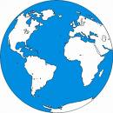

Water
Day and night

