GEOGRAPHY PLANNING – WATER/RIVERS
YEAR 5 SPRING 2008

ICT LINKS COLLABORATIVE LEARNING STRUCTURES MATHS LINKS

Cross Curricular Links

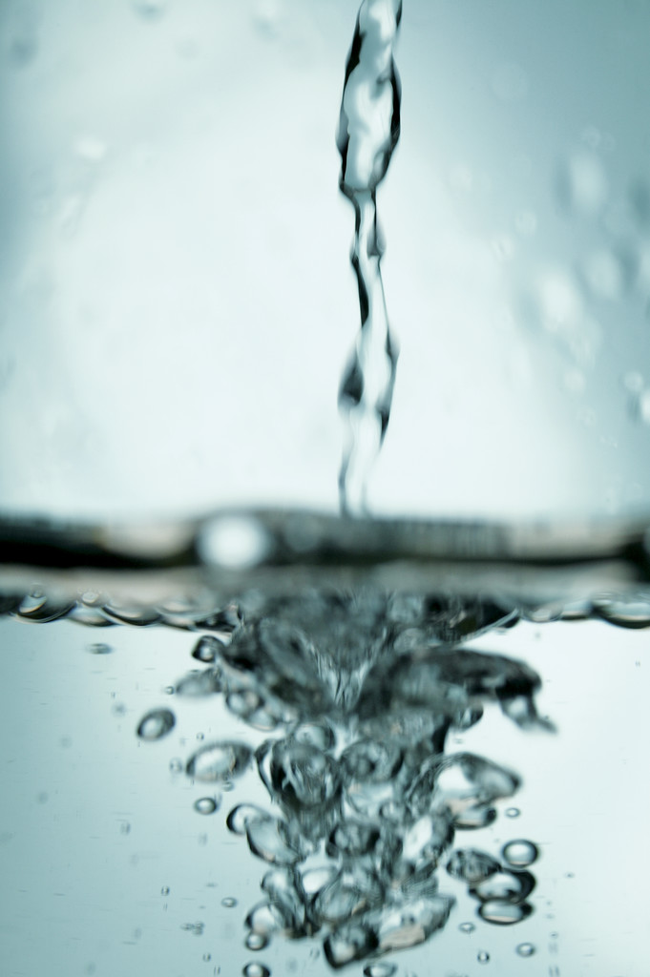
Literacy – Explanation Text – the water cycle
ICT – internet research
Maths – Measure & Data Handling
Science – Changing State & Gases around us
History – the Middleton Flood
R.E. – uses of water

Texts to use for Guided Reading:

Week 6: Water is precious leaflet (Northumberland water)
Week 7: water facts leaflet (Northumberland water)
Week 8: water for health
Week 9: fortune teller
Week 10: Rochdale Canal (wow for water)

Useful websites

http://www.oxfam.org.uk/education/resources/water_for_all/
http://www.wateraid.org/uk/learn_zone/teachers/key_stage_two/default.asp
http://www.kented.org.uk/ngfl/subjects/geography/rivers/
http://www.wow4water.net/grownups
http://www.channel4learning.net/sites/essentials/geography/units/rivers_bi.shtml
http://www.woodlands-junior.kent.sch.uk/Homework/Grivers.html#1

Week/  Lesson/  main focus | Learning objectives  WALT | Success criteria  WILF | Main teaching activity | Independent work (groups, pairs, individuals) | Plenary | Evaluation/ next steps
W6  L1  science | - to know that materials can be classified as solids, liquids and gases  - represent knowledge of solids, liquids and gases in a concept map  - to know the terms ‘melting’ and ‘freezing’ and recognise that they can be reversed | - describe the differences between solids, liquids and gases  - explain when evaporation occurs and describe it in terms of liquids changing to gases | Show children SNF 1 – can you sort these objects into groups and explain your reasons? Show SNF 2 & 3  Review children’s understanding of solids, liquids and gases by asking them to draw a concept map using terms eg solid, liquid, gas, melt, freeze, water, ice, change, cool, warm, flow, change shape, volume, , evaporate. Discuss their maps with the children using specific examples to clarify what they know. Introduce the term ‘state’ to describe solid, liquid and gases. | RECORDING: Concept map/mind map  Title page  solid, liquid, gas, melt, freeze, water, ice, change, cool, warm, flow, change shape, volume, powder, evaporate, state  Properties of solids and liquids sheet | Extended plenary: smart notebook on solids, liquids and gases
W6  L2  Sc/  geog | ~ To understand the process of evaporation (and condensation) which are reversible  - To identify and sequence the components of the water cycle | - explain the water cycle in terms of the processes of evaporation and condensation and appreciate the reversibility of these two processes; | Where does water come from?  The water cycle. Listen to explanation of water cycle on igniting writing – explanation text | Water Cycle (Worksheet 3 St Helen’s)  This worksheet checks if children have an understanding of processes involved in water cycle. It also links to work on solids, liquids and gases (Unit 5C). | SNF 11 – learning log activity: water cycle circle or cartoon, see  Hotcourses.com (snf 12)
W6  L3  science | - to make careful observations and draw conclusions explaining these in terms of scientific knowledge and understanding  - To understand the process of evaporation (and condensation) which are reversible | - identify the process which takes place when liquid turns into water vapour as evaporation | Where does water go to? Puddle investigation  What happens to the puddles in the playground after it stops raining? Where does the water go to? How could we set up an experiment which would compare the size etc of puddles?  Set up experiment – measure at different times during the day | RECORDING: Write-up of experiments including graph  (in the case of dry weather, use the following from St Helen’s. Otherwise, use in plenary)  Puddles worksheet (St Helen’s)  The worksheet illustrates evaporation by chalking round the edges of puddle at intervals as it evaporates. Children to predict the size of the puddle at a given time.  N.B. During discussion, pupils may use the word ‘disappear’ to describe evaporation. However, it is important that pupils understand that although puddle has disappeared, the water has evaporated into the air. | Teacher led discussion on what happened and why? Children to interrogate graph and record answers. Predict what will happen if weather conditions were different.  Point out to the children that graphs can be used as a predictive tool.
Week/  Lesson/  main focus | Learning objectives  WALT | Success criteria  WILF | Main teaching activity | Independent work (groups, pairs, individuals) | Plenary | Evaluation/ next steps
W7 L1 | - To use observations to draw conclusions | - Can the children construct a fair test measuring variables? | Evaporation investigation – changing where water is placed  How could we test the rate of evaporation of water? Use post – it poster system and discuss the concept of a fair test | Evaporation Rates  (Worksheet 2 – St Helen’s)  Children to look at information on the table provided and decide on the variables they would change, measure and keep the same. | Review fair test – look at examples from St Helen’s
W7 L2 | - to make careful observations and draw conclusions explaining these in terms of scientific knowledge and understanding | Can the children construct a fair test measuring variables? | Evaporation investigation – changing type of liquid | RECORDING: Write-up of experiments, with graphs | Water and vinegar investigation sheet – homework? (St Helen’s)
W7 L3 | - To know how water is used in the world  - To investigate similarities and differences  - To understand that water is a universal need | - I can list as many different water uses as I can think of  - I can sort my list into different categories | Uses of water/ how much water do we use?  Whole class – compile a list of the various uses of water | Divide children into groups and ask them to sort the list into categories – home, farms, industry, leisure, others  Use round table | Homework – keep a diary of water use in the home for a week. Explore the issue of wasting water.
Week/  Lesson/  main focus | Learning objectives  WALT | Success criteria  WILF | Main teaching activity | Independent work (groups, pairs, individuals) | Plenary | Evaluation/ next steps
W8  L1 | - to obtain information from maps and an atlas | - use the index to locate main oceans and rivers | Where can we find water? Locally? In the world?  To appreciate the amount of the Earth’s surface cover by water, play ‘the world in your hands’ game – throw and catch inflatable globe – check your right index finger – is its tip touching land or water? | Consensus mapping – brainstorm where we find water. Come up with agreed main places.  Identify world oceans and main rivers in Atlases | Label oceans and rivers on IWB map
W8  L2 | - to obtain information from maps and an atlas:  - about world weather patterns  - about physical and human features | - I can find the wettest places in the world  - I can mark the main deserts of the world on a map  - I can draw temperature and rainfall graphs for different countries | Where in the world has a lot of rainfall? Very little? Medium? (use atlases)  (driest is <250mm per year)  shade 3 zones on a map. Discuss wettest areas. | Using an atlas  Identify main deserts around the world ( Atacama, Kalahari, Sahara, Arabian, Thar and Australian). Compare with areas shaded in first part of the lesson. What does the map show?  Rainfall - graphs
W8  L3 | - to obtain information from maps and an atlas:  - to obtain information from the internet | - to obtain information from the internet:  - use search engine  - identify key features of rivers  - use note taking skills | What can you tell me about rivers? What are rivers used for?  What is a river, why are rivers important, what do rivers carry, how are rivers formed?  Name rivers locally, in the UK, around the world  Locate on map (IWB world map) | World rivers – internet research | Homework – the world’s major rivers
Week/  Lesson/  main focus | Learning objectives  WALT | Success criteria  WILF | Main teaching activity | Independent work (groups, pairs, individuals) | Plenary | Evaluation/ next steps
W9 L1 | - how rivers erode, transport and deposit materials producing particular landscape features |  | Features of a river – journey  use powerpoints from click teaching: river journey/ along the river  Where is this river? Where does it go? What are the different features of a river? How is it changing?  Ask children to note changes in height/ width/ water  Consider different sections along the river course  Human use along the river | Draw sketch maps of a river and label the main features
W9 | - to observe and question  - to collect and analyse evidence  use secondary sources |  | River visit – Daisy Nook  Where is this river? Where does it go? What are the different features of a river? How is it changing?  Ask children to note changes in height/ width/ water  Consider different sections along the river course  Human use along the river
Week/  Lesson/  main focus | Learning objectives  WALT | Success criteria  WILF | Main teaching activity | Independent work (groups, pairs, individuals) | Plenary | Evaluation/ next steps
W10  L1 | - to observe and question  - to collect and analyse evidence  - use secondary sources |  | Canal visit – Rochdale canal  (resource: wow for water) | What are the differences between rivers and canals?
W10  L2 |  |  | Middleton flood

