Homework ideas for Year 4 learning logs.

I realise this isn’t a unit plan, as I would be mad to do that for homework, but these are the types of tasks I give for my learning logs homework. First I send this letter home for the parents, with tips from the learning logs website:
Learning Logs
This year your child’s homework will be based on a more creative approach. They will each have an A4 book called a Learning Log. Each week I will give them a task with an aim or learning objective that they should reach. They complete this task in their logs, but in any creative way that they choose, written, fold out charts, pictures, diagrams etc. It should be in the neatest handwriting and well-presented as it is a piece of work, but as long as they reach the aim given, it is otherwise very flexible and suits all styles of learning and ability. The task will always be relevant to our current theme, and we will share the logs on a Friday afternoon so the children learn from each other.
Here is an example of a child’s log and her comments:
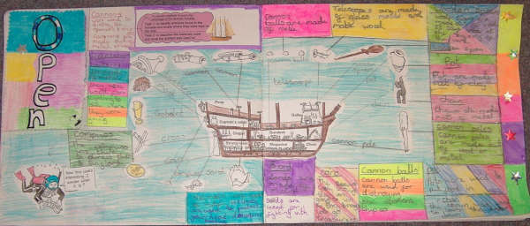

“My name is Jessica. I am nine years old. I love my learning log. I do my best handwriting in it. I have lots of pullouts which I think make it very interesting to read. Even if I go out somewhere, I still find time to do it. One Saturday evening I was working on it at 10 o clock at night! On a Saturday when I go to town I spend my birthday money on craft items to put in it. Laura and Nicole, my friends, share the learning objectives over the phone. I also put in extra exiting stuff. For example when I have been to any places, like Crufts dog show, I get leaflets to stick inside it. I really enjoy spending any spare time I have working on my learning log. I make it colourful with coloured paper.” An example from www.learninglogs.co.uk

As you can see from the above examples it is very bright and colourful, and as the child says she adds any other exciting things that may be unique to her, explaining what she has learned from the experience.

Below are examples of tasks I set.

L.O: To understand that the Aztecs had different beliefs to ours.
Task: Find out what Aztecs believed in, write about it and draw pictures. If you can find any stories we’d love to hear them!

L.O: To design a creature to live in the Amazon rainforest
Task: The rainforest is home to a huge amount of amazing creatures who have changed the way they look or behave over hundreds and thousands of years so that they are well suited to live in the rainforest. This process is called evolution.
Your task is to “design” a new creature that could live in the rainforest.
You might want to think about the following things before you begin:
1. Is your creature a bird, a mammal or an insect?
2. Which part of the rainforest will your creature live in? Will it live in the trees or on the floor?
3. What will your creature eat? Will it be a producer, consumer or predator?
4. What colour will it be? Is it camouflaged?
5. Is your creature nocturnal or awake in the day?
6. What will the name of your creature be?

L.O: To write a diary entry as an historical character.

Write a diary entry for the day the Spanish invaded Tenotichtlan. You may be either an Aztec or a Spanish soldier. Imagine what it was like leading up to the attack, during and after. What did you do? What happened to you after the attack? How did you feel? Add illustrations and diagrams (eg maps of the city) as you feel necessary. You could also try to make your page look like it comes from 1521!

L.O: To write an explanation text.

Choose a simple activity to explain eg. Brushing your teeth. Use time connectives, paragraphs, correct spelling and diagrams to explain the activity. You can add pictures from magazines or your own, or you can make it more interesting with fold out sections, lift-the-flaps or pop outs.

L.O. To know what a ‘habitat’ is.
Task: In your learning log show what you know about the word habitat, draw pictures or design a habitat to show you understand what it means. What does a habitat need? What different kinds of habitats are there?

L.O: To know which forms of measurement to use around the house.
Task: Spend some time thinking how you would measure day to day things, like how long is an episode of Doctor Who, or how much flour do you put in a cake mix, or how tall is each member of your family.
Measure some different things around the house and record what you have done in an exciting way. Don’t forget to use the correct abbreviations e.g. m for metres, g for grams etc.

L.O: To be able to show understanding about historical events.

Task: Research any area of World War Two that interests you and present it in a style of your choice. You have two weeks for this homework.
You could choose the war at home, the war in Africa, Japan, children during the war, rationing, or any other topic.

L.O. To create a page of a newspaper.

Task: Create the page of a newspaper. It can be a news item,
a picture page with captions, a sports report
or a relaxing page including things like cartoon strips,
crosswords, horoscopes etc.
Give your newspaper a name, try to make your articles
realistic, interview someone if you like and lay it out
in the style of a newspaper with columns etc.

L.O: To be able to find numbers in the world around us.
Task: Find out some numbers from World War II e.g. the war started in 1939 and ended in 1945. How many children were evacuated? How many people died in prison camps? etc. Think about how you can present this in an exciting way.

L.O: To know the properties of 2d and 3d shapes.

Design a chart to show that you understand the properties of 2d shapes, include different names the shape may be known by. Maybe have separate colours for shapes with similar properties.
Make your pages colourful and neat, always use a ruler. Can you make any 3d shapes to pop out?

L.O: To be able to show understanding about historical events.

Task: Think about why wars start, how can you show some of the reasons that wars begin between two or more nations.

Write about Christmas in the country you are from, traditions, stories, songs, food etc. You can also tell us about family traditions you have. Have fun!

