Year: 5

History : Unit 19 What were the effects of Tudor exploration?

 | Objective (WALT) | Resources | Success Criteria (WILF)/Activities | Outcome
Session 1 | - How did knowledge of the world change during the Tudor period?  to compare the knowledge of the world that people had in Tudor times with what is known today  - the context of the voyages of Tudor explorers  - that exploration in the sixteenth century led to better knowledge of the world | 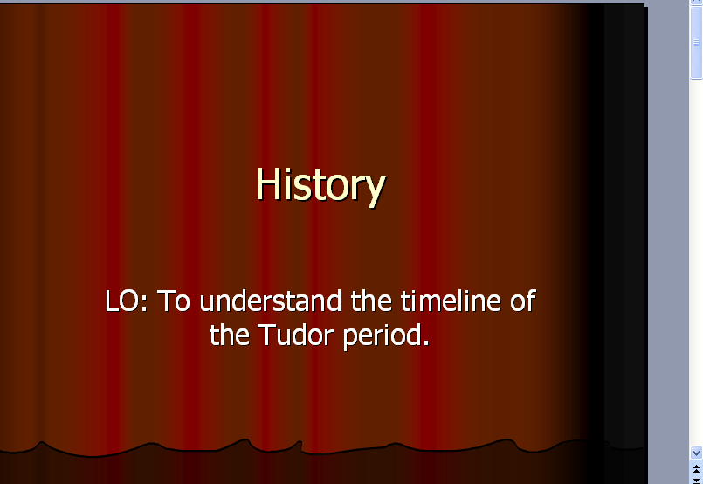 | B: I can complete four facts on a timeline  A: I can place a number of events on a timeline  G: I can research and complete a timeline. | All groups to produce a timeline of events.
Session 2 | Why did the Tudors explore outside Europe?  to locate the Tudor period in relation to other periods of British history  reasons for Tudor exploration | 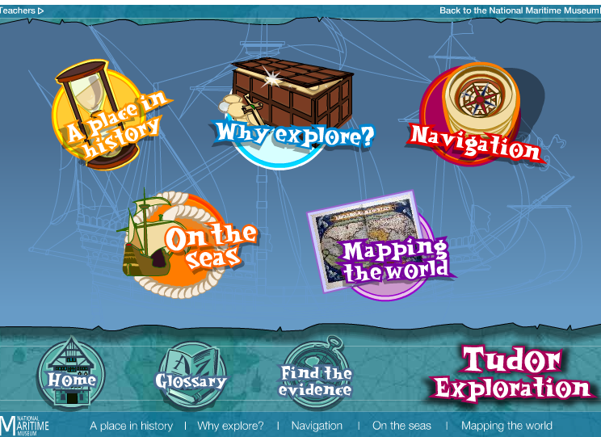  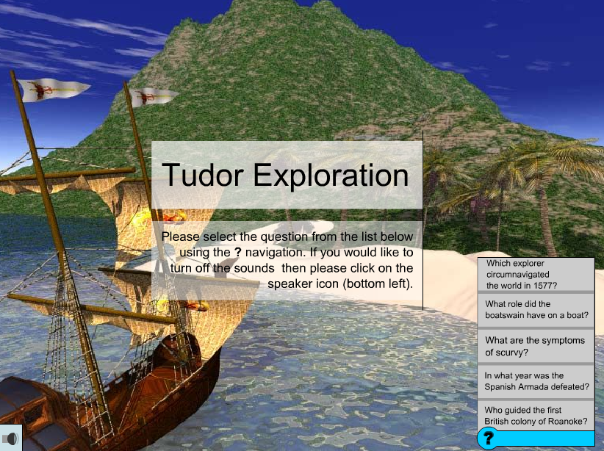 | B: I can use secondary sources to research the Tudor period.  A: I can use secondary sources to research the chronology of Tudor times.  G: I can use secondary sources to research lives | B, A and G groups to produce a Tudor fact file in PowerPoint.
Session 3 | How did people explore the world in Tudor times?  to collect information from a range of sources and draw conclusions about life at sea  - to appreciate the dangers and discomfort of voyages of exploration  - to communicate their knowledge and understanding in a variety of ways | 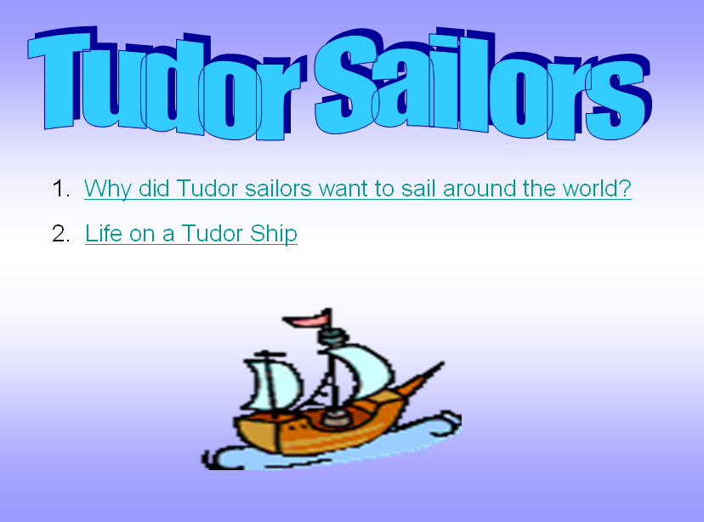 | B: I can talk about the life of a sailor.  A: I can write a journal entry from a sailor’s POV.  G: I can write a persuasive job advert for Tudor sailor. | B: Produce comic strip identifying aspects of life on ship.  A: Write a journal entry.  G: Produce a job advert.
Session 4/5/6 | http://tre.ngfl.gov.uk/server.php?request=cmVzb3VyY2UuZnVsbHZpZXc%3D&resourceId=10317  Why did Drake circumnavigate the world?  about the main events in Drake's voyage around the world  - to apply their understanding of chronology  - to infer reasons why the voyage took place | 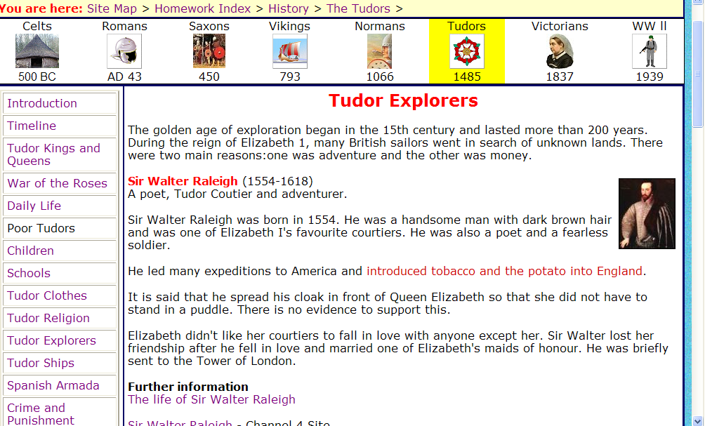  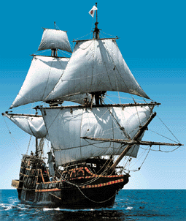 | All gps to write a newspaper article (differentiated support on website: trainee newshound➔veteran hack). | 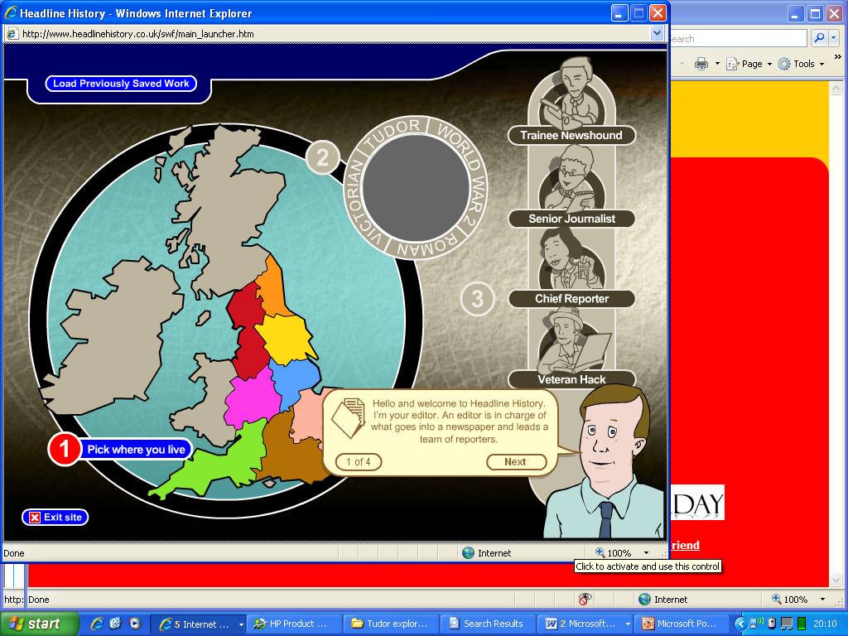
Session 5 | Why did the Roanoke settlement fail?  to apply their knowledge and understanding of settlement in England to a new context - settlement in America  - to understand the difficulties that faced the settlers in Roanoke  - to explore the causes of the failure of the colony | 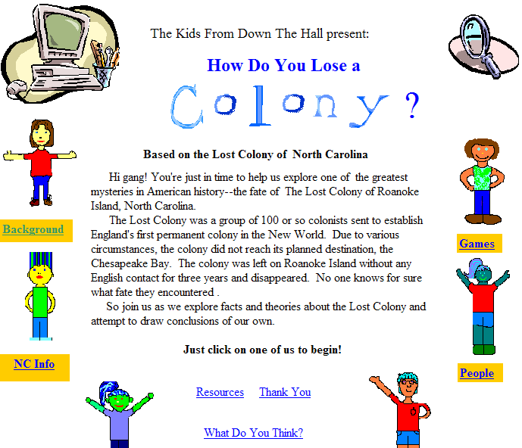 | B: I can list a number of reasons why the settlement failed.  A: I can choose the reason why Roanoke failed and give reasons why.  G: I can write from a settler’s POV and solve the history mystery. | B/A: use webquest and helper sheets to identify.  G: use evidence available to support theory (also use 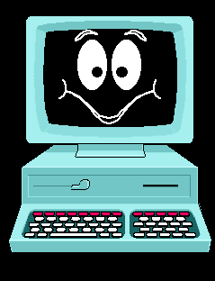
Session 6/7 | What were the effects of the English settlement on the people living in America?  to find out about the ways of life of indigenous peoples before colonisation  - to consider how the English settlers viewed the indigenous people  - to compare and contrast very different perspectives of the same event  1➔ Jamestown chronology  2➔ Economics/conflict | 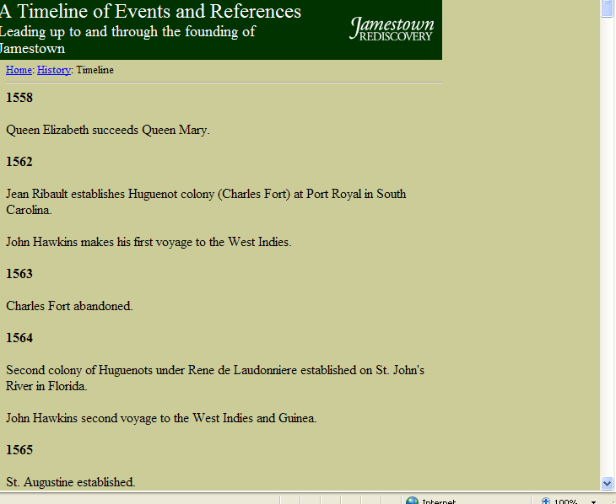  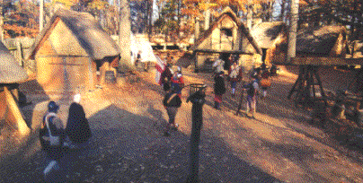 | B: I can write from an English settlers POV.  S: I can identify points for and against for new colonies.  C: I can plan a discussion re colonies. | Identify different POV.
Session 7 | What impact has Tudor exploration had on our lives today?  to recall and summarise what they have learnt about voyages of exploration  - to select appropriate material and to present it to show their understanding of exploration in the Tudor period and its impact on life today |  | Three columns No impact/impact/unsure (-ve and +ve impacts)

Cross Curricular Links

Science – Healthy Eating
Literacy – persuasive writing, comic strips, journal entry, POV

Name: Date:
HUMANITIES QUIZ – TUDOR EXPLORATION
YEAR 5 – SPRING

- Fill in the table below for each time period by writing YES if Europeans knew about that continent and NO if they didn’t.
 | Europe | Asia | Africa | America | Australia
Middle Ages | YES | YES | YES | NO | NO
Late Tudor times
Modern times

- Match the following people to their reasons for exploring.

1 – A merchant 2- A priest 3- A Spanish conquistador 4- The Queen

I will discover and conquer new lands. The King will reward me when I claim new lands for Spain.
Riches from across the sea will make my realm more powerful and strong against its enemies.

I believe God wants me to convert the natives to Christianity.
Far away countries have things we want to buy, like fur, gold and spices. I can sell them cloth and weapons in return.

- Imagine you are a merchant living in England in Tudor times.
  - Draw circles around the four things in the box that you can buy in places like India, America or Africa and sell for high prices back in England.
  - Draw rectangles around two things in the list that you can buy in England and sell to people in far away countries.

GOLDWEAPONSLOTS OF FURS

SPICESSLAVESWOOLLY CLOTH
- Tick the things that would have made people want to go and settle in the ‘New World’. Put a cross next to the things that would have put people off.

  - In the New World you are free to worship God in your own way.
  - There is lots of land there, so you could have your own farm.
  - The journey is dangerous.
  - The native people are sometimes hostile.

- Write down 2 things from this list that Tudor explorers didn’t have because they hadn’t been invented.

MOVABLE SAILS – to steer the ship even if the wind is blowing in the wrong direction.
COMPASS – to show which way is north.
GPS – satellite positioning system to show where you are.
QUADRANT – to find position by looking at the stars.
RADIO – to keep in contact with the shore.

a) …………………………………………. b)………………………………………………….

- Match the two parts of each sentence.

In Tudor times …… ….with heavy wind and weather on long voyages

Ships were much…… …..England’s ships got much better.

They could now cope ….. ….bigger and better designed.

- In this script the Captain is trying to persuade an older sailor to join his crew for one more voyage. Decide what he says. Put a C for Captain, S for sailor.
…….”Join my ship and see the world!”
…….”I’ll be lucky not to see the inside of a sea monster.”
…….”There will be plenty of salt beef and bacon to eat.”
…….”Not to mention biscuits crawling with maggots and water green with scum.”
…….”Never mind, there’s always barrels of wine.”
……..”But drunk sailors won’t obey your orders. Then they’ll be cruel punishments.
………”Nonsense! You know me, gentle as a lamb. Why, I hardly hanged anyone last voyage. It was mostly just floggings.”

- Fill in the blanks in this statement by Drake, by using the words in the box.

Drake wasn’t just an explorer. He wanted to capture Spanish ships carrying gold and …………………………….. across the Pacific Ocean from America home to …………………………………… . The Spanish thought that only they knew the way to the ……………………………….. . They would be taken completely by surprise. The Drake could raid Spanish treasure and please the Queen.

PACIFICSILVER
SPAIN

- Put these sentences in date order. The first has been done for you.

- In 1580 Francis Drake arrived home. The Spanish complained about his raids, but Queen Elizabeth was so pleased with the treasure Drake gave her that she made him a knight and he become known as Sir Francis Drake.
- Ferdinand Magellan had been the first to circumnavigate the globe in a journey from 1519 to 1522.
- The Golden Hind captured many Spanish treasure ships.
- In the Pacific, three ships were lost in storms, and one turned back. Just one ship was left; the Pelican. Drake renamed it the Golden Hind.
- Drake left England with five ships in 1577. He followed Magellan’s route to the Pacific Ocean.

Order. 1)B 2) 3) 4) 5)

- Look at this list of ways for the Roanoke settlers to stay in touch with England.
REGULAR POSTAL SERVICESRADIOINTERNET

ASKING A PASSING SHIP TO CARRY A LETTER

Which of these was the best method of keeping in touch?

- Put these things of the colonists plan in the correct order.
Things to do
Arrange a temporary shelter e.g. a tent.
Arrange permanent shelter e.g. a log cabin.
Collect a group of people who want to emigrate.
Buy seeds to take with you to plant.

Years before:…………………………………………………………………………………………………………………
Months before you leave:……………………………………………………………………………………………
Before first night falls on
the first day you arrive:………………………………………………………………………………………………
Before the first winter:………………………………………………………………………………………………
- The Roanoke settlement failed because of many reasons. Fill in the blanks below using words from the box.
ReasonSpanishAmericacolony

ThreatRoanokeget on
The …………………………….settlement was England’s first attempt to found a
…………………………………….. in ……………………………………… . One reason it failed was because it was under …………………………….from the …………………………………. .
The most important ……………………………….. it failed was that the settlers and natives did not ………………………………with each other.

- Tudor discoveries made enormous changes to the way of life back home. Decide which of these changes were good and which were bad. G for good, B for bad.

A - Shipbuilding got much better.
B – There was much more respect for science because people had seen what it could do.
C – Tobacco was introduced to Europe.
D – Many people went to a better life in America.
E – New foods were bought to Europe such as maize and potato.
F – European diseases killed many Native Americans.
G – Slavery, which had almost disappeared from Europe, came back.

