Numeracy Planning Sequence (3 week block) | Classes: | Year Groups: 5 |  | Teachers: Mrs James | Week: | Beginning: 21 April
Block E Securing Number Facts relationships and Calculating
Curricular Targets
Must: Know by heart all multiplication facts up to 10 × 10; derive quickly corresponding division facts.
• Recognise multiples of 6, 7, 8, 9, up to the 10th multiple.

Should: Multiply and divide whole numbers by 10 and 100 and explain the effect. Use this to be able to multiply by multiples of ten and 100 and explain their answers. Derive quickly doubles of two-digit decimals (e.g. 3.8 × 2, 0.76 × 2), and the corresponding halves.
Could: Multiply and divide whole and decimal numbers by 10 and 100 and explain the effect. Use this to be able to multiply by multiples of ten and 100 and explain their answers. Be able to explain the relationship between two numbers eg 4.6 and 46.
Learning Outcome
Children double and halve decimal numbers using their knowledge of doubling and halving whole numbers and decimal place value. They find, for example, double 0.47 and half of 7.2. They answer questions such as:
Find a number whose double lies between 1.3 and 1.4.
What number lies halfway between 2.47 and 2.83 on a number line?
Children count in fractions. For example, they count from 0 in steps of ¹⁄₄ initially using improper fractions (0, ¹⁄₄, ²⁄₄, ³⁄₄, ⁴⁄₄, ⁵⁄₄, …) and then using mixed numbers (0, ¹⁄₄, ²₄, ³⁄₄, 1, 1¹⁄₄, …). They record the count on a number line to establish equivalent pairs, e.g. 2³⁄₄ = ¹¹⁄₄. They discuss how to find equivalent pairs without a number line, establishing that 1 whole is equivalent to 4 quarters, so 2 wholes is 8 quarters (4 quarters × 2), and 2³⁄₄ is equivalent to 8 quarters + 3 quarters, or 11 quarters. They use diagrams where helpful to confirm the equivalent improper fraction for a given mixed number and vice versa.
Children relate fractions to their decimal equivalents. They recognise that fractions with a denominator of 10 or 100 can be converted to their decimal equivalent by placing the digits of the numerator in the appropriate column, e.g. ³⁄₁₀ = 0.3, ⁷⁄₁₀₀ = 0.07, ¹³⁄₁₀₀ = 0.13. They use number lines (or the ITP ‘Fractions’) to establish the decimal equivalent of fractions such as ²⁄₅ or ¹⁄₂₀.
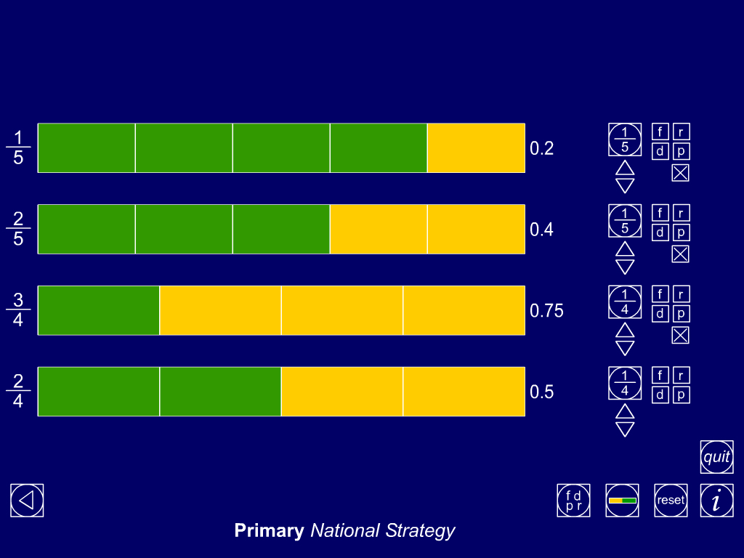
For example, they use a 0 to 1 number line marked in steps of 0.1, divide it into fifths and mark ¹⁄₅, ²⁄₅, … on it. They use this to establish that ¹⁄₅ = 0.2, ²⁄₅ = 0.4, … They use the patterns in such sequences to predict other equivalents, predicting, for example, that ⁴⁄₅ will be equivalent to 0.8. Children understand how to use a calculator to convert a fraction to a decimal. They appreciate that ⁴⁄₅ is equivalent to 4 ÷ 5. They appreciate that when they key this calculation into a calculator it will give them the answer in decimal form. So one way to find the decimal equivalent of ⁴⁄₅ is to key 4 ÷ 5 into a calculator.
Children solve problems involving fractions, including some where the calculations merit use of a calculator. For example, they find ²⁄₃ of 150 ml by dividing 150 ml by 3 to find ¹⁄₃, then multiplying the answer by 2 to find ²⁄₃. They solve problems such as:
Jay buys a 2 litre bottle of pop. He drinks ¹⁄₄ of the bottle and spills ²⁄₅ of the bottle. How many millilitres are left?
A mile is 1760 yards. I have walked ⁵⁄₁₁ of a mile. How many yards is this?
Children understand percentage as the number of parts in every 100. They represent particular percentages using practical resources such as money (£1, 10p and 1p coins) or images such as a 10 by 10 square grid, for example shading 35 squares in the grid to represent 35%. To find the percentage equivalent for simple fractions such as ³⁄₄ they shade this fraction of a 10 by 10 grid and consider what percentage this represents. Children appreciate that 10% is equivalent is ¹⁄₁₀, so to find 10% of an amount they can divide it by 10. They find 10% of numbers and measures such as £2.00, 150, 25, 700 ml, 3 kg. They begin to use 10% of an amount to find 5%, then 20%, 30%, … They use this method to work out percentages of quantities such as 20% of 1 kg, 30% of 200 ml, 5% of £80.
Children recognise and interpret the vocabulary of ratio and proportion, using diagrams or objects to represent the situation. They understand that scaling involves increasing a quantity by a given factor. Multiplication by 5 means scaling a number or quantity by a factor of 5, and making it 5 times as big.
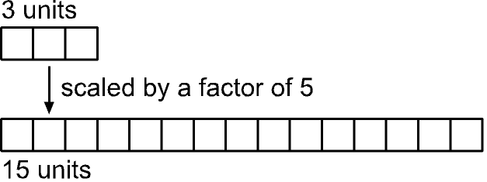
They use pairs of number lines to show scaling, for example by a factor of 3:
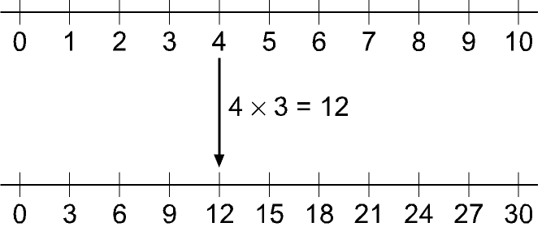
They scale up a relationship such as ‘There are 3 red sweets in every pack of 10’ to establish that there would be 6 red sweets in every 20 sweets, 9 red sweets in every 30 sweets, and so on. They solve problems such as:
At the gym club there are 2 boys for every 3 girls. Suggest some numbers of boys and girls that there might be at the club.
A mother seal is fed 5 fish for every 2 fish for its baby. Alice fed the mother seal 15 fish. How many fish did she feed to the baby?
Paul uses 3 tomatoes for every ¹⁄₂ litre of sauce. How much sauce can he make from 15 tomatoes? How many tomatoes would he need for 4l of sauce?
Mental Oral Objective (at least 2 to be related to CT)  I can double and halve two-digit numbers and explain how to use this to double and halve related decimals  Use a calculator to solve problems, including those involving decimals or fractions (e.g. find ³⁄₄ of 150 g); interpret the display correctly in the context of measurement  I can use a calculator to find the decimal equivalent of a fraction  Double and halve 2 digit numbers including decimals |  |  | Learning Objectives for direct teaching  I can explain how to turn a mixed number such as 2³⁄₄ into an improper fraction. I can draw a diagram to support my explanation  Express a smaller whole number as a fraction of a larger one  (e.g. recognise that 5 out of 8 is ⁵⁄₈); find equivalent fractions  (e.g. ⁷⁄₁₀ = ¹⁴⁄₂₀, or ¹⁹⁄₁₀ = 1⁹⁄₁₀); relate fractions to their decimal representations  I can give the decimal equivalent of a simple fraction such as ³⁄₁₀ and explain how I know  Understand percentage as the number of parts in every 100 and express tenths and hundredths as percentages  I know that ‘per cent’ means ‘parts in every 100’, so 1% = ¹⁄₁₀₀  I can give a simple fraction such as ¹⁄₁₀ as a percentage  Use sequences to scale numbers up or down; solve problems involving proportions of quantities (e.g. decrease quantities in a recipe designed to feed six people)  I can continue a sequence such as: ‘There are 3 red sweets in every 10, there are 6 red sweets in every 20’
Speaking and Listening – (How can you develop talk around maths in your class this?) |  |  | Vocabulary  problem, solution, calculator, calculate, calculation, equation, operation, symbol, inverse, answer, method, explain, predict, reason, reasoning, pattern, relationship  add, subtract, multiply, divide, sum, total, difference, plus, minus, product, quotient, remainder, multiple, common multiple, factor, divisor, divisible by  decimal fraction, decimal place, decimal point, percentage, per cent (%)  fraction, proper fraction, improper fraction, mixed number, numerator, denominator, unit fraction, equivalent, cancel  proportion, in every, for every, to every
Prior learning
use diagrams to identify equivalent fractions, e.g. ⁶⁄₈ and ³⁄₄, or ⁷⁰⁄₁₀₀ and ⁷⁄₁₀; interpret mixed numbers and position them on a number line, e.g. 3¹⁄₂ NEEDS TEACHING
• use decimal notation for tenths and hundredths and partition decimals; position one- and two-place decimals on a number line
• know the equivalence between decimal and fraction forms of one half, one quarter, tenths and hundredths
• double and halve two-digit numbers CT
• use written methods to record, support and explain multiplication and division of two-digit numbers by a one-digit number, including division with remainders, e.g. 15 × 9, 98 ÷ 6 (morning activity)
• use the vocabulary of ratio and proportion NEEDS TEACHING

 |  | Direct Teaching | Guided Work with teacher | Independent Work or TA supported groups | Plenary/Probing Qs.
DAY 1 | Consolidate prior learning | Probing Question/Images  Fractions ITP  Fractions ppt | Seals  Use cubes to create improper fractions and mixed fractions  Order on a number line.  How do I know this fraction is 3/4?  How do I  Know this fraction is 1and 1/4 ? What is this as an improper fraction? | Dolphins Whales  Identify improper and mixed fractions, place on a number line wsheet  Anna, Hugh & Travis – extension for improper and mixed fractions | What mixed number is equivalent to 1³⁄₄? How do you know?  How many sevenths are there in three wholes? What calculation does this involve?  Find an improper fraction that lies between 3 and 4.  Sam says that 2³⁄₅ is equivalent to ¹³⁄₅. Explain how he found the numerator 13.
DAY 1 | Consolidate prior learning | M.O. use a calculator to find fractions of a number  L.O. I can convert improper and mixed fractions  Revise vocab for fractions LW  Identify simple fractions using cubes/ folded paper  Show fractions Itp – what fraction is this?  What is this fraction as a decimal?  Next show improper fractions as 1 1/6 & 7/6  Repeat with 13/5. Why do we call this an improper fraction?  Show number line and count out 1/5ths as marked on.  Count on as 6/5ths; 7/5ths etc  Repeat as mixed fractions, 1 1/5; 1 2/5  Using number line what is the same as 1 and 2/5?
DAY 2 | Consolidate prior learning | M.O. I can double numbers – play doubling around the room – use language twice; 2x; double  L.O. I can order mixed numbers  Show http://www.primaryresources.co.uk  /maths/powerpoint/mixed_fractions.swf  On a no. line where would I place 21/2?  31/2?; 11/4?  Explain that markers are needed – start with whole numbers and then mark in divisions – explain equal parts for a fraction.  Repeat with no. loine 10 – 20 and ask children to mark in 131/4, 151/2, 173/4 | Dolphins  Draw number line 10cm long with divisions every 2cm  Label 0-5  Label with mixed fractions  How do you know where to position the fractio? What part of the number doyou need to look at first?  Extend with 1/3rds | Whales  Repeat for Dolphins but use 1/3rds and 1/8ths  Seals  Position 1/2s and 1/4s on a number line | On a number line 0-1 where would you place 1/3? How would you divide up the line? Why?  How would you know where to place 1/8th? 1/16th?  Where could we place 3/4?  3/8? 2 and 3/16?
DAY 2 | Consolidate prior learning | Probing Question/Images  Which part of the number do you look at first for ordering on a number line?
DAY 3 | Consolidate prior learning | Probing Question/Images  If I know 1/3rd of 9 is 3 how can I work out 2/3rds of 9  http://www.freewebtown.com/weddell/mw/decimals/fraction%20of%20amount.swf | Whales  Start with finding eg 3/8 of 64; 4/9 of 63; 1/5 of 45  What calculation are you doing?  What skills do you need to be successful with this?  Tgt maths pg 27 section C | Dolphins  Find simple and multiple fractions of numbers eg 1/4 of 32; 3/4 of 24.  Move onto Tgt maths pg 27 B1 – B12  Seals  Tgt maths pg 27 section A | ¹⁄₃ of 75 is 25. Write this as a division statement.  What operation would you key into a calculator to find ¹⁄₈ of 256?  One seventh of a number is 4. What is the number?
DAY 3 | Consolidate prior learning | M.O. Pairs – decimal number on the IWB – show me what you need to add to this to make 1.0  L.O. I can find a fraction of a number  Revise finding a simple fraction of a number eg 1/2 of 8… ÷ by 2.  1/4 of 8…. ÷ by 4 . What do I do to find 1/3rd of a number. Demo with 9 children at front.  If we can find 1/3rd of 9, how can we find 2/3rds of 9?  Using calculator what is  2/3 of 15? 24? 36?
DAY 4 | Assess + review | Probing Question/Images  Fractions ITP | Whales Dolphins and Seals  Use a calculator to find equivalent decimal fractions.  Highlight the fractions / decimals they think will be useful to learn  Ext: Tgt maths pg 22 section A |  | Discuss findings – did any of the fractions have the same decimal equivalents? Eg 1/5 = 2/10 = 0.2 show using diagram on IWB  What calculation would you key into a calculator to find ³⁄₂₀ as a decimal?  Use a calculator to establish whether ²⁷⁄₄₀ is bigger or smaller than 0.75.
DAY 4 | Assess + review | M.O. I can add decimals to make 10  L.O. I know the equivalence between decimal and fraction forms of one half, one quarter, tenths and hundredths  Write 2/10 on the board – how can I express this as a decimal.  Explain that calculators are useful for converting fractions to a decimal equivalent. Reinforce part of 1  Eg 1/2 of £1 is £o.50.  Explain fraction is the numerator divided by the denominator. Key in 1 ÷ 2. On f/c show 1/2 = 0.5  Repeat for 1/10 and 1/4  Then show for 1/3 and discuss repeating decimals – need to round to 2 dp  What would 1/7 be as a decimal fraction?
DAY 5 | Direct teaching | Probing Question/Images  http://www.freewebtown.com/weddell/mw/decimals/tenths-hundredths.swf | Whales Dolphins and Seals  Play http://www.freewebtown.com/weddell/mw/decimals/tenths-hundredths.swf in mixed ability pairs  Work alongside seals  Also challenge maths pg 18 HOMEWORK |  | What are the fraction equivalents for 0.7; 0.4; 0.6; 0.65; 0.25  Why can’t 0.65 be represented as tenths?  Using calculator does 2/5 have a tenths equivalent?  6/20?
DAY 5 | Direct teaching | M.O. Double decimal numbers  L.O. I can recognise equivalent decimals and fractions  7/10 on the board – what does this mean?  Is it greater or lass thn 1/ How do you know?  Repeat for 70/100.  How would I write 70/100 as a decimal?  If I had a cake would you like to eat 7/10ths or 70/100ths? Use calculators to demo =.  Show 70/100 = 7/10 as each number can be divided by 10
DAY 6 | Direct teaching | Probing Question/Images  Ppt equivalent fractions | Seals  Find simple fractions for tenths and fifths | Dolphins  Find simple fractions for tenths and fifths  Whales  Convert fractions for sixths ninths etc  Cteaching | Write 1/4; 1/2; 3/4 on the board.  How many equivalent fractions can you find?  What did you do to the numerator and denominator each time?
DAY 6 | Direct teaching | M.O. double decimals eg 2.5, 11.5; 2.25, 0.25  What happens when we double a number with 0.5; 0.25?  L.O. I can convert fractions  Run through ppt  Explain they need to know x tables and recognise a common denominator | Seals  Find simple fractions for tenths and fifths
DAY 7 | Practice, investigate and apply | Probing Question/Images  Ppt fractions of 100  Fractions ITP – show dec & % | Whales  Tgt maths pg 29 B | Dolphins & seals  Calculator and fraction cards and 100 squares  Find fraction as a decimal and shade on 100 square | What is 0.15 as %?  Otgher examples, mixture of fractions and decimals to convert into %
DAY 7 | Practice, investigate and apply | M.O. double decimal numbers  A number when doubled gives 9.2, what was the number? Same for 4.8; 6.4; 11.6?  L.O. I can understand percentages as a fraction of 100  Introduce percentages as part of 100. Show ppt  Show equivalents Revise tenths and hundredths as fractions and decimals. Use blank 100 square to shade in 10/100 as 10%.  So 1/10 = 0.1=10%  Learning Wall chart | Whales  Tgt maths pg 29 B
DAY 8 | Practice, investigate and apply | Probing Question/Images  Fractions ITp | Dolphins  Tgt maths pg 30 B  Work together | Seals  Challenge pg 54  Whales  Tgt maths pg 30 B | Find 75% of 200 ml. How did you do this?  What percentages can you easily work out in your head? Talk me through a couple of examples.
DAY 8 | Practice, investigate and apply | M.O. halve 2 digit numbers and decimals –show on wbs  L.O. I can find a simple percentage (50%, 25%, 75%, 10%) of a quantity  75 is the same as 75/100 or 0.75. 25% is the samew as 25/100 or 0.25.  refer back to yesterday to make link that 75% = 3/4; 50%=1/2; 25%=1/4;10%=1/10.  This means we can find 50% of a number using these facts ie 50% = 1/2, so 50% of 30 is 50 ÷ 2 =15.  What is 10%0f 60? 25% of 60? | Dolphins  Tgt maths pg 30 B  Work together | Seals  Challenge pg 54  Whales  Tgt maths pg 30 B
DAY 9 | Practice, investigate and apply | Probing Question/Images | Shade 10% of this grid.  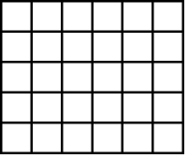  Which is bigger: 65% or ³⁄₄? How do you know?  What percentage is the same as ⁷⁄₁₀? Explain how you know.  What is ³¹⁄₁₀₀ as a percentage?  Which is a better mark in a test: 61%, or 30 out of 50? How do you know?
DAY 9 | Practice, investigate and apply | M.O. I can find equivalent fractions, decimals and %  L.O. REPEAT YESTERDAY
DAY 10 | Assess + Review | Probing Question/Images | Whales, Seals & Dolphins  Differentiated word problems from P& E, CgfL  Eg Here is a chocolate bar.  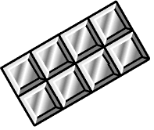  Bill eats 3 pieces and Ann eats 2 pieces.  What fraction of the chocolate bar remains?  Mark ¹⁄₃ and ⁵⁄₆ on this number line.  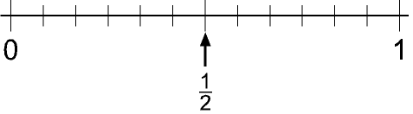  Tell me two fractions that are the same as 0.2.  How would you write ³⁷⁄₁₀₀ as a decimal?  Tell me a fraction that is equivalent to ²⁄₃ but has a denominator of 9. How did you do it? |  | Discuss any difficulties, strategies used to solve the problems
DAY 10 | Assess + Review | L.O. I can solve problems involving fractions  Jay buys a 2 litre bottle of pop. He drinks ¹⁄₄ of the bottle and spills ²⁄₅ of the bottle. How many millilitres are left?  A mile is 1760 yards. I have walked ⁵⁄₁₁ of a mile. How many yards is this?  CALCULATOR
DAY 11 | Consolidate learning | Probing Question/Images  Fractions itp – show rp part | Seals  Use cubes to make patterns and isentify the ratio and proportion for each one  Write on WB  PHOTO | Dolphins  Prepared multilink – copy and co;our on book Write ratio and proportion for each tower  Whales  R & P wshhet | 4boys, 3 girls  What is the ratio of boys to girls? What is the proportion of boys?  Add one more boy, one more girl and repeat.
DAY 11 | Consolidate learning | M.O. I can explain how to turn a mixed number such as 2³⁄₄ into an improper fraction and vice versa  L.O. I can use the vocabulary of ratio and proportion  Introduce ratio as one for every  If I have one blue cube for every 3 then the ratio is 1:3 –m show with cubes  Show different multilinks.  What fraction of the stick is blue? 1/4 what fraction is red? 3/4 This is the proportion ie 1/4 of my stick is blue; 3/4 is red  Demo with cubes and IWB
DAY 12 | Securing and extending understanding | Probing Question/Images | Dolphins  Colour in sweet bags showing ratios  Discuss solving ratio problems  Ct sweets | Whales  Colour sweet ratios; solve problems Ct  Seals  Colour sweet ratios; | There afre 30 children in a clas with a ratio of 2:1 girls to boys. How many girls and how many boys are there?  What strategies would we use to solve this?
DAY 12 | Securing and extending understanding | M.O. I can calculate a fraction of a number  L.O. I can continue a sequence such as: ‘There are 3 red sweets in every 10, there are 6 red sweets in every 20’  Bag of sweets  2 maltesers for every 3 minstrels. Ratio of 2:3 (5sweets in total)  New sweet product is always produced in this ratio.  Double size os sweet packet. How many maltesers? Minstrels? (10 sweets in total)  I now have 10 maltesers, how many minstrels would I have?
DAY 13 | Securing and extending understanding | Probing Question/Images | Whales, dolphins, seals  Smartie game! |  | Play human ratios
DAY 13 | Securing and extending understanding | M.O. I can identify the ratio and proportion of a coloured tower  L.O. I can use the vocabulary of ratio and proportion  In a tea shop there are 7 cakes or biscuits on each plate. They are in a ratio of 3:4 biscuits to cakes.  Draw thia plate to show this.  What is the fraction or proportion of the cakes? |  |  | Play human ratios
DAY 14 | Assess + Review | Probing Question/Images | Whales, dolphins, seals  Differentiated word problems Sch and PR  Support as necessary  Draw a diagram that shows this statement: ‘My necklace has 2 yellow beads for every 3 green beads.’  There are 20 girls and 10 boys in a class. Describe this with a sentence that uses the words ‘for every’.  You earn one voucher for every £20 you spend at a shop. How much must you spend to get 4 vouchers? Tell me how you worked this out.  One orange costs 15 pence. How much would five oranges cost? |  | What is the definition for ratio? Proportion?
DAY 14 | Assess + Review | M.O. I can double numbers  L.O. I can solve problems involving R & P  I have 20 cakes on a plate and 1/5 of them are chocolate. The rest are plain. How many cakes are plain?  Discuss |  |  | What is the definition for ratio? Proportion?
DAY 15 | Assess + Review | Probing Question/Images | Continue from yesterday
DAY 15 | Assess + Review | Repeat as yesterday | Continue from yesterday
PROGRESSION FOR NEXT TERM

