Lesson Plan - Making a Circuit for the Lighthouse
Lesson Focus:  - Identify common appliances which use electricity  - Construct and make drawings of simple working circuits  - Explain why some circuits work and others do not | Lesson Objectives:  - To make a circuit using a battery wires and bulbs  - To record observations in drawings  - To predict and then test if a circuit will work
Resources/Equipment:
Whiteboard activities (W1, W2)
The Lighthouse Keepers Lunch - (black sheet of paper on page where Mrs Grinling appears to represent when light house fails)
Electrical components to make a complete circuit
Differentiated worksheets:
- Can You Help Mr Grinling? (1i - iii)
- Mr Grinling has a go? (2i – ii)
- Will it work ? (3i - iii)
Introduction
Classification exercises using the whiteboard
What have all these pictures got in common? (light producers)
Which of these need electricity? (whiteboard activity.
Which of these are battery operated/main operated? (whiteboard activity 2)
Discuss the dangers of mains electricity with the children
Sorting activity
Main
Read first part of The Lighthouse Keepers Lunch. Dilemma the lighthouse light fails - What could happen? (ideas re shipwreck etc) What caused lighthouse light to go out? (Children’s possible answers - power out, bulb broke, big wave came) How could e solve this problem - (use battery powered circuit as a back up)
Task - You have to show Mr Grinling how to do this.
Activity 1:
- Children to make a model of how to light up bulb – Differentiation – Mixed pairs/children who are more able could get own equipment
- Children to draw circuit when have successfully lit the bulb. (1i – 1iii).

Activity 2:
- Teacher modelled explanation of will it work sheet using single example (2i-2ii)
- Give the children Mr Grinling has a go!. They have to decide whether or not they think (predict he was successful or not) differentiated sheets. Test circuits to see if they were correct.

Plenary:
- Feedback from children on circuit diagrams – will it/won’t it work? (2i/2ii). Sort large images
- Children are encouraged to use specific language to say why it will/wont work e.g. it is a complete circuit, the wire isn’t touching the bulbholder.
- Children have to predict whether the bulb will light up in diagrams (3i-3ii) (and more able give reasons for answers)

Levels:

Level 1 | - Construct a circuit with help.  - Identify common appliances which use electricity.
Level 2 | - Identify common appliances which use electricity.  - Construct and make drawings of simple working circuits  - Explain why some circuits do/do not work.
Level 3 | - Construct and make circuits which have more than one component  - Suggest how we could make a homemade switch to make light house flash

Wilf: Can you help Mr Grinling? (1i)

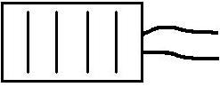
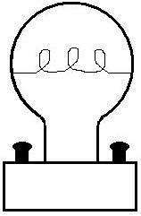
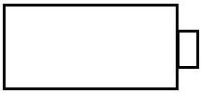

buzzer
battery

bulb
wire

Make a circuit to light a bulb or sound a buzzer.

Draw a picture of your circuit and label the equipment.
Wilf: Can you help Mr Grinling? (1ii)

wire

bulb
battery

Make a circuit to light a bulb.

Draw a picture of your circuit and label the equipment.
Stick the word label in the right place.

bulb

wire

wire

battery
Wilf: Can you help Mr Grinling? (1iii)
Make a circuit to light a bulb.
Cut out the equipment and stick it into the right place.

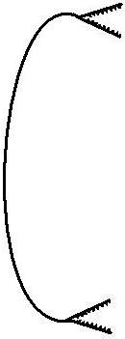
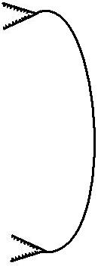
battery
bulb
wire
wire
Wilf: Mr Grinling has a go! (2i)


Will it work? Test

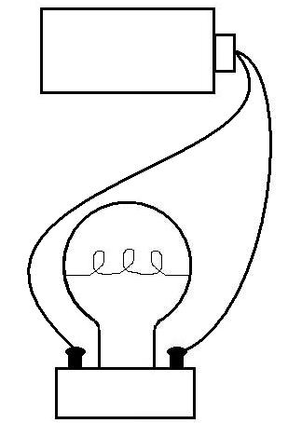
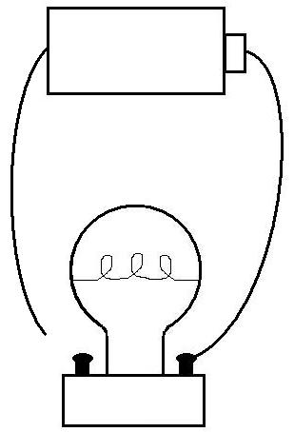

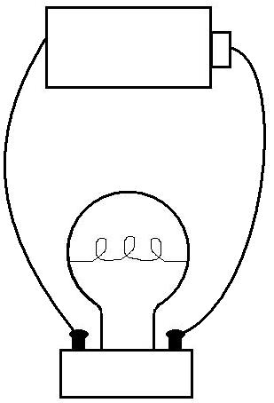
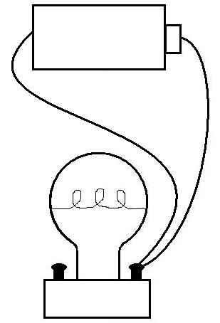

Will it work? Test

Will it work? Test

Will it work? Test

Will it work? Test

Wilf: Mr Grinling has a go! (2ii)
Will it work?……………………………

Why? …………………………………………
……………………………………………………
……………………………………………………
Test

Will it work?……………………………

Why? …………………………………………
……………………………………………………
……………………………………………………
Test

Will it work?……………………………

Why? …………………………………………
……………………………………………………
……………………………………………………
Test

Will it work?……………………………

Why? …………………………………………
……………………………………………………
……………………………………………………
Test

Wilf: Will it Work? (3i)

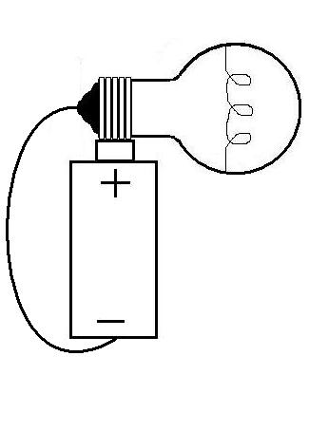
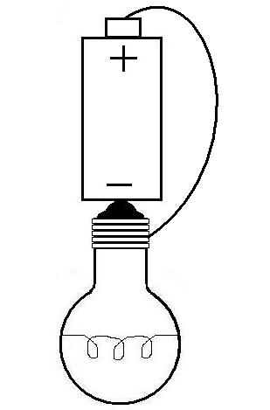

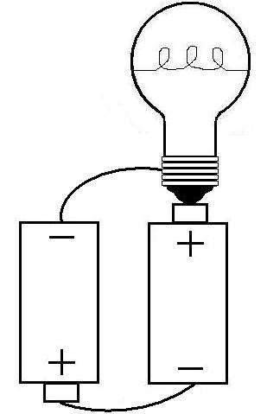
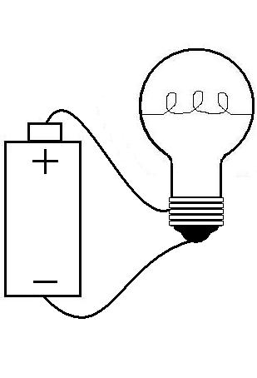

Will it work? Test

Will it work? Test

Will it work? Test

Will it work? Test

Wilf: Will it Work? (3ii)
Will it work?……………………………

Why? …………………………………………
……………………………………………………
……………………………………………………
Test

Will it work?……………………………

Why? …………………………………………
……………………………………………………
……………………………………………………
Test

Will it work?……………………………

Why? …………………………………………
……………………………………………………
……………………………………………………
Test

Will it work?……………………………

Why? …………………………………………
……………………………………………………
……………………………………………………
Test

Will it work? Test

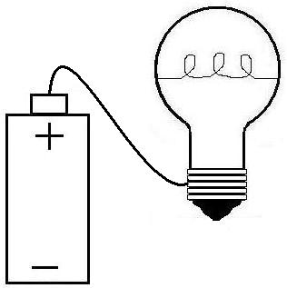
Will it work? Test

Will it work? Test

Will it work? Test

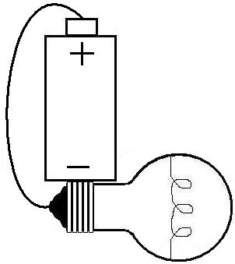
Will it work? Test

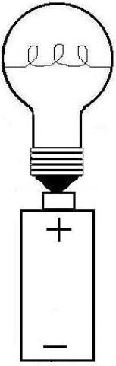
Will it work? Test

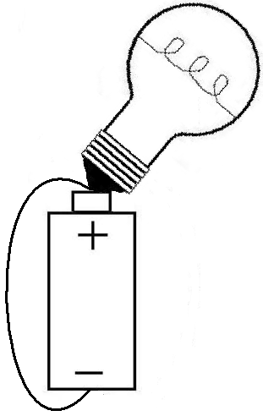
Will it work? Test

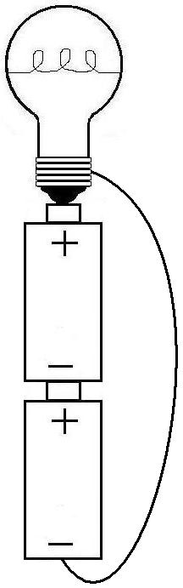
Will it work? Test

Will it work? Test

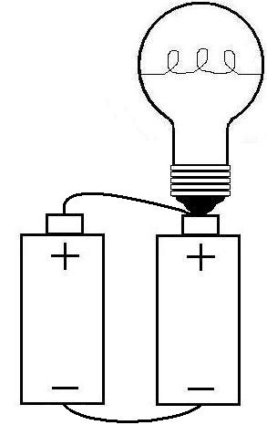
Will it work? Test

Wilf: Identify which use electricity?

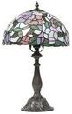



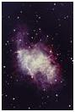




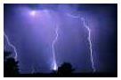
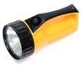

Wilf: Identify which use mains or Battery Power?

