Year 4 Creative Curriculum Medium Term Plan
Topic: World War Two

Key Objectives
- To understand about characteristic features of the periods and societies studied, including the ideas, beliefs, attitudes and experiences of men, women and children in the past. (His 2a)
- To identify and describe reasons for, and results of, historical events, situations, and changes in the periods studied. (His 2c)
- To recognise that the past is represented and interpreted in different ways, and give reasons for this. (His 3)
- To know how to find out about the events, people and changes studied from an appropriate range of sources of information, including ICT based sources, e.g. documents, printed sources CD-Roms, pictures, photographs, music, artefacts, hisotric buildings and visits to museums. (His 4a)
- To ask and answer questions, and to select and record information relevant to the focus of the enquiry. (His 4b)
- To recall, select and organise historical information. (His 5a)
- To communicate knowledge and understanding of history in a variety of ways. (His 5b)
Display Opportunities  Photos from WW2 day/trip to imperial war museum.  Propaganda posters | Important Vocabulary  allies, Chamberlain, Churchill, Hitler, Roosevelt, Stalin, Hirohito, Mussolini, aeroplanes, armaments, Blitz, blitzkrieg, bombs, evacuation, evacuees, munitions, air raid, Anderson shelter, Morrison shelter, siren, billeting officer, gas mask, host family, ration book, coupons, ARP warden, blackout, propaganda, identity card, land army,  Dance vocab: motif = a simple movement or action, which you can develop or link with other motifs to make a phrase; unison = everybody does the same action at the same time; canon = dancer A starts the sequence and dancer B joins in after A has completed one phrase, and dancer C joins in after B has completed one phrase etc. gesture, mirroring, levels, rhythm, improvisation.

Day | Input | Learning Activities | Review, extend and celebrate | Resources | Product
History focus  What was the Second World War? | L.O. To establish what we already know, and what we would like to find out. | Intro – History detectives  Share learning objective for the lesson (ppt). and give lesson overview: mystery object, group discussion to prepare for whole class concept map, short presentation giving an overview of World War Two, summary of learning so far.  Sort children into five groups (talking partners together). Explain that each group has a mystery object to examine that is associated with the topic. 3 mins to explore and then be able to answer 3 key questions:  - What is your object?  - Who would your object have belonged to?  - What would he/she have used it for?  Report back to class.  Main  Reminder about working in groups. Go through 6 key questions children will discuss in groups. They can jot down notes on paper if they want. (15 mins)  - What do you already know about WW2?  - When did WW2 begin? / end?  - Why did Britain go to war with Germany?  - Why is it called a ‘World War?’ Which countries were involved?  - Who were the key people in WW2?  - What would you like to find out?  On IWB use 2simple software to record existing knowledge/things to explore.  Follow-up: print this out and display on Working Wall. | Watch presentation ‘A Civilians’ War’. Finish with w/b relay – writing up key words that we have already used. | Ppt lesson one. Mystery objects from museum loans box (Gas Mask,  Torch, set of cigarette cards,  policeman’s helmet,  gas attack warning rattle), cloths to cover them, history detectives cards and key questions.  Whiteboard timer  large sheets of paper for notes, felt tips.  2simple file ‘World war two overview’,  ppt ‘A Civilians’ War’ from Writing Non-fiction CD-Rom  music and whiteboard pens for plenary. | Concept map of children’s current understanding that can form basis for discussion in future lessons.  Children have had a brief look at objects which can then be placed in the ‘I wonder…’ corner.
P.E. focus  Dance: During the Blitz Lesson 1 | L.O. To explore and create characters and narratives in response to a range of stimuli.  Dance to be performed to parents at end-of-unit celebration. | Intro  Play Neville Chamberlain’s speech (CD track 5) – use powerpoint presentation from lesson one with image of N.C. making speech. How do you think the people might have felt when they knew Britain was at war with Germany? What did people do when they heard the sirens? How could you show these feelings and emotions through facial expressions and body language? Explain that this is the track that will start the dance. You will need to think about an interesting starting position e.g. sitting next to the radio, looking out of the window. Hunched shoulders, worried expressions.  Warm-up  Walk to a space, freeze, turn and walk to another space (repeat). Increase the pace and jog on the spot. Jog to a space, freeze, turn and jog to another space. Encourage children to find a space before they freeze. Stretch arms and legs and shake them out. Revise why warm ups are important. Repeat activity, this time pretending to slowly find your way in the dark, creeping along in silence. Freeze in an interesting position, changing levels. What might you be doing? e.g. picking up a bag, holding onto a rail. Children in 3 rows, one behind the other. Together, pretend you are creeping slowly down the steps to the London Underground station. Remind to hold onto rail or someone’s hand. Repeat until can all creep in time with each other.  Main  Play track 5 again – children to decide on interesting starting position (as discussed in intro). Play track 6 – this is when they will have to jump up to grab gas masks and belongings and creep towards Underground shelters. Creeping in the dark, but still moving fairly quickly. Listen carefully to the music and pick out the slow, quiet notes of the harp. This is when everyone walks in unison down the stairs to the underground. Practise the movements. Split class into two groups so children can perform in front of each other. Those watching to look for good spacing, facial expressions, changes of direction and interesting frozen positions.  Cool down  Jog gently. Slow to a brisk walk and then a gentle pace, keeping good posture. Freeze and stretch arms up one at a time. Now raise both arms slowly together while inhaling. Exhale as you bring arms down again. Repeat.  Follow-up  Introduce dance vocabulary to the class – display opportunity |  | LCP KS2 3&4 Dance CD.  CD player.  Classroom display –dance vocab. | Children have:  - thought about character and narrative ideas, and responded through movement.  - linked actions to make dance phrases.  - used different compositional ideas to create motifs incorporating copying and unison.
Music focus
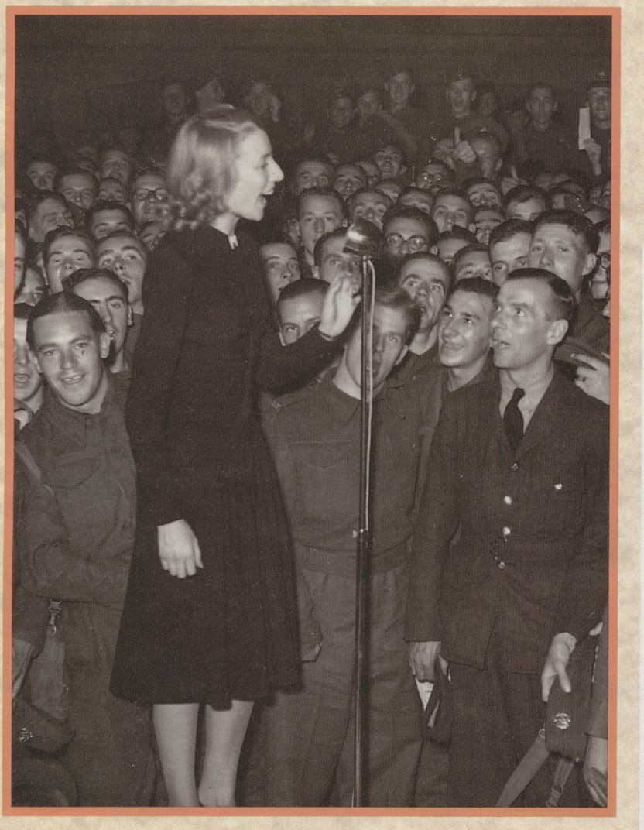
WW2 songs
History focus  Leaders and countries | L.O. To know about the leaders, key events and dates of the war. | Intro  Recap learning from previous session using presentation features of 2simple software and keywords that children listed at the end of last lesson. Have timeline displayed on the Working Wall, and with children add three key dates from presentation watched in previous session.  Give overview for this session, and share learning objective/outcomes. (ppt Lesson 2)  Main  Show map of the world. Remind children that it was a world war because soldiers, sailors and airmen from many countries fought in it, and it was fought in many places. List with children some of the names of the countries involved (Great Britain, USA, Australia, Soviet Union, India, Italy, Japan, New Zealand, France, North Africa, Poland, Germany etc). Identify where they are on the map). Children given enlarged copies of flags and world map (LCP p353). Explain how the key for colouring them in works, and show how the finished piece of work is to look for inclusion in WW2 project book.  Follow-up/Morning work  Children to copy shared writing of sentences identifying leaders from the War. | Display pictures of key people. Establish who they were – shared writing of sentences that children can copy for morning work. | key dates to add to timeline.  ppt Lesson 2  red, blue, black, green, yellow pens/pencils.  Flags, Finished example of how their work should look – enlarged, pictures of leaders, enlarged world map, copies of key people tables for children to complete, scissors.
History focus  The Blitz 1 | L.O. To locate where bombing raids took place and to understand the characteristic features of the Blitz. | Intro  Explain that ‘Blitz’ is short for Blitzkrieg which means ‘lightning war’ in German. What do you think a ‘lightning war’ is? Talk partners: Imagine you are a german pilot. Rank these places in the order of importance for bombing. Be able to explain why you have chosen to put them in that order:  - munitions factory  - other types of factory  - ports  - fields  - rivers  - large cities  - farms  - historic buildings  Overview of lesson, including L.O. and outcomes.  Main  Watch ppt presentation ‘the Blitz’ from Writing Non-fiction CD-Rom. Divide children into 3 groups. Each group given series of pictures of the Blitz. Group 1 brainstorms nouns, Group 2 brainstorms verbs, Group 3 brainstorms adjectives. Share and write up as whole class word webs.  Picture matching activity – in hometable groups match the captions to the right pictures of the Blitz.  Follow-up work: Once checked, children can do their own versions neatly as morning work. | Dress the ARP man (primary resources website)  Give children copies of the match the gas mask activity. | ppt presentation ‘the Blitz’ from Writing Non-fiction CD-Rom  Enlarged slides from Blitz Literacy powerpoint.  Englarged captions and pictures from ‘Blitz Photo Sort’, plus copies of this for individual children.  Match the gas mask activity sheets. | word webs for future use in creative writing about experiences of people in the war.  Blitz photos for inclusion in World War 2 project books.
P.E. focus  Dance: During the Blitz Lesson 2 | L.O. To explore and create characters and narratives in response to a range of stimuli. | Intro  While children get dressed, show slide show of life in the shelters with sound effects. Discuss how people kept their spirits up and carried on as normal during the Blitz/air raids.  Warm-up – Game: traffic lights. Children respond in different ways to different coloured cards: Green: children steer their ‘cars’ in and out of everyone else with quick little running steps; Amber: slow creeping steps; Red: stop the car and put the brake on. Follow with stretches to the music of track 7. Play again, and this time ask children to improvise in time to the music e.g. pretend to play an accordion, drum or piccolo. Walk in time to the music, playing imagined instrument, turn and walk in a different direction. Repeat the track, this time children work with a partner and mirror each other, doing the movements together. Ask children to make up some motifs that can be developed into a phrase e.g. mirroring, then skipping off together. Choose children to demo movements and praise. Partners now develop ideas based on what they have seen from rest of class.  Main  Children sit and listen (reminded to sit with straight backs). Recap dance from last session, i.e. starting positions listening to radio, then grabbing gas masks and belongings. Children find a space and creep with you in the dark, then step slowly together down the stairs into the London Underground shelters. Ask children to find starting position. Tell them you are going to play tracks 5, 6 and 7. Let children dance to the music and help them by calling out instructions. Encourage good use of space and changes in direction and levels. Explain that when they hear track 7, they must find their partner and do their practised phrases. Split class into two groups (keeping partners together). One group performs while rest of class watches. Remind observers to look for spacing, changes in levels and direction and good timing. Encourage suggstions for improvements (3 stars and a wish). Swap over.  Cool down  Children lie on their backs, stretching their arms over their head. Stretch arms and legs together and feel the tension in whole body. Hold the stretch for a count of five and then relax. Repeat. Ask children to get up very slowly, keeping eyes looking down at the floor and brining heads up last. Stand in a space and concentrate on good posture. Notice good examples and ask those individuals to line up first. |  | Slide show with images from the Blitz and London Underground shelters.  LCP KS2 3&4 Dance CD.  CD player.  Red, orange, green cards | Children have:  - explored and developed a wide range of actions, varying and combining spatial patterns, speed, tension and continuity when working on their own and with a partner.  - performed short dances with expression showing an awareness of others when moving.  - remembered, practised and combined longer, more complex dance phrases.
History focus  The Blitz 2 | L.O. To understand about the effects of air raids and the causes of evacuation. | Intro  Recap learning about the Blitz, referring to dance lessons and word webs. Watch short video clip from ‘Children in the Second World War’. Have enlarged map of the UK. Stick gold stars on bombed cities and label them. Discuss why they were targets.  Main  Play soundclips of air raid siren and ‘all-clear’. Discuss the difference in the two sounds. Show pictures of the Anderson shelter and Morrison shelter. Children have w/bs. Read the ‘child’s view of the Coventry Blitz’. While they are listening, children make notes about what they could see, hear, smell, feel in the shelter. Share ideas. Now complete the sheet (from Interactive History Whiteboard Resources). Less able to do group version – shared writing with support. | Children read out their descriptions.  Shared reading of government instructions for building Anderson shelter – Link to Goodnight Mister Tom DVD. | gold stars  labels for map  Large UK map.  Video – children in the second world war.  Copies of sheets from Interactive History (see, hear, smell, feel)  individual whiteboards.  Government instructions (enlarged). | Descriptions of being in an air-raid shelter for inclusion in World War Two project book.
P.E. focus  Dance: During the Blitz Lesson 3 | L.O. to improvise in groups, to join movements together to tell a story through dance. | Intro  While children get dressed, show slide show of the war effort. Discuss what people are doing in the pictures. Reminder of key dance vocabulary (refer to classroom display)  Warm-up  Stretches. Play track 7 as ‘follow-my-leader’ in small groups, miming playing musical instruments and gradually increasing the pace in time with the music. Give children time to work with their partner, recap their movements to track 7 from last lesson.  Main  Group partners into groups of 6 max. (mixture of boys and girls). Ask the groups to think of a ‘war effort’ theme and make up a dance movement for it e.g. digging for victory, working in a munitions factory, fighting at the front on land or in the air. Play track 8, and ask the children to work out a group movement. This could be in unison, mirrored, copied, or in canon). Ensure groups have enough space. Explain that when the ‘all-clear’ sounds (track 9), the children stop what they are doing and make their way out of the shelter individually, in pairs or in groups. Split class in two (as in previous sessions) to give opportunities for evaluation and feedback.  Cool down  Whole body stretch lying down on floor (as per lesson 2). Hamstring stretch by bending front knee forwards and keeping back leg straight. Change over. |  | Slideshow of pictures showing ‘the war effort’.  LCP KS2 3&4 Dance CD.  CD player. | Children have:  - linked actions to make dance phrases, working with a partner and in a small group.  - used different ideas to create motifs incorporating unison and canon  - experimented with a wide range of actions,  - performed short dances with expression, showing an awareness of others when moving.
History focus  Evacuation | L.O. To find out about the experiences and feelings of evacuees from a wide range of information sources. | Links: Literacy work on recounts, Goodnight Mister Tom video. See file ‘Numeracy ideas linked to WW2’ – problem solving, data handling, time etc.  Intro  Show section of ‘The Home Front’ ppt presentation (Writing Non-Fiction CD-Rom) that focuses on evacuees. Play whole class game ‘I packed my suitcase for the country, and in in I put…’ Discuss fact that children couldn’t take everything and had to leave some belongings behind.  Main  Use ‘suitcase’ template from Whiteboard History CD-Rom. Children write about the objects they would pack in their suitcase.  Follow-up: Write a postcard home to tell your family about your first day. (Tea stained?) | Play steam train sound clip.  What have you chosen to put in your suitcase? Why?  Play soundclip of Princess Elizabeth’s radio broadcast. | Sound clips  Images of Evacuation  Copies of suitcase template.  Postcards for follow-up work (tea stained?) | Children have list of what they would pack in their suitcase. Links to literacy work, visit to Imperial War Museum and WW2 day – children will have empathised with what it would have been like for them 70 years ago.
P.E. focus  Dance: During the Blitz Lesson 4 | L.O. to perform dances with awareness of rhythm and expression; to describe, interpret and evaluate their own and others’ dances. | Warm-up  Stretches followed by game: ‘One Behind’ – children each in a space. Teacher begins performing an exercise or stretch as the children stand at attention. When the teacher switches to a different exercise, the students begin performing the exercise the teacher did previously. (e.g. jumping jacks, jogging on the spot, punches in front etc)  Main  Ask children to sit near you and, while listening to the music, talk through each section of the dance worked on in previous session. Talk about being in character, and discuss how the children could refine their dance e.g. facial expressions. Decide together how the dance is going to finish when they hear the ‘all clear’. What are your feelings when you come out of the shelter? Think about creating interest through use of different levels, spacing and body shapes. Give children time to practise in their groups. Watch each group in turn – teacher to video each group.  Cool down  Stand in a space and stretch out arms at the sides. Bend elbows and bring hands into chest. Now rotate upper body to the left and to the right. Repeat. Follow with leg stretches.  Follow-up  With each group, watch the video of them dancing. Discuss possible improvements and what aspects work really well. |  | LCP KS2 3&4 Dance CD. Warm up music.  CD player.  Video camera. | Children have:  - remembered, practised and combined longer, more complex dance phrases.  - communicated through dance and performed with fluency and control, showing sensitivity to the music.  - incorporated different dynamics into their dance.
History focus  Rationing | L.O. To explain why rationing was necessary, and its impact on the lives of people living in England during WWII. | Maths link: converting lbs and oz to kg and g, weighing (1oz = 25g, 1lb = 500g, 1pint = 20 fl oz)  PSHE link – saving money  Intro  Look at pictures of 1940s food packaging – which brands do you still recognise? Key questions: What was rationing? Do you think it was a good idea? Why? What foods were/weren’t rationed? Could people grow these foods themselves? Where? Add dates to timeline – 8th January 1940 food rationing introduced, 26th July 1942 rationing of sweets began. Show examples of ration books. Look at world map. Where do you think certain foods came from? e.g. cocoa (Brazil), tea (India), rice (China), Bananas (Jamaica), Meat (New Zealand), potatoes (Britain). Talking partners: list 5 of your favourite foods/drinks that you would find it difficult to be without, or have to eat less of.  Main  Divide children into 5 groups. Give each group a ‘thinking hat’. How do you think people would have felt about rationing from this perspective? What kind of things would they say? Fill in speech bubbles.  White hat – facts and figures; Black hat – being cautious, identifying problems; Red hat – emotions; Yellow hat – looking for the advantages; Green hat – creative thinking, suggestions. Feed back to class.  Weigh out with the children one adult’s food ration for a week (link to maths – weighing and measures). Explain that in addition to this simple rationing, there was also a points system for things like tinned goods, biscuits, syrup and treacle etc, and that some foods e.g. milk, dried milk, eggs, dried eggs and oranges were made available to those who needed them most. Which groups of people would that be?  Watch sections from ‘’Children in the Second World War’ video: How did Everyone help? and What was rationing?  Carry out the ‘Rationing challenge’ on bbc website: www.bbc.co.uk/history/ww2children/ration/ration_intro.shtml  Follow-up: Sheet on Potato Pete and Dr Carrot. Homework? | The sailors gave nicknames to the food or ingredients. Ask the class to guess which words match up? Ask them to draw a line to join up the pairs of real- and nick-names. Rum = grog; Butter = slide; Sweets = nutty; Cocoa = kye; Biscuits = hard tack; Haddock = yellow peril; Steak and kidney = baby's heads. | Enlarged world map; images of foods to guess where they came from.  Speech bubbles for thinking hats  Weighing scales, adult’s food ration: 100g bacon/ham, 50g butter; 50g tea; 3½ pints milk; 225g sugar; 350g meat; 100g cheese; 50g margarine; 75g sweets; 1 egg.  Camera | Digital photos of children measuring out food ration for a week. Children have explored a question from a range of perspectives.
D&T focus
War-time recipe
P.E. focus  Dance: During the Blitz Lesson 5 | L.O. to perform dances with awareness of rhythm and expression; to describe, interpret and evaluate their own and others’ dances. | Having watched videos of group dances, use time to perfect performances. |  | LCP KS2 3&4 Dance CD. Warm up music.  CD player. | Children have:  - remembered, practised and combined longer, more complex dance phrases.  - communicated through dance and performed with fluency and control, showing sensitivity to the music.  - incorporated different dynamics into their dance.
History focus  The Home Front | L.O. To explain how the war affected people’s everyday lives. | Intro  Go through ‘The Home Front’ ppt presentation (Writing Non-Fiction CD-Rom). Look at various examples of WW2 propaganda posters. Who is the target audience? Men, young people? mothers? workers? How do you know? Why was this message important to get home to people?  Main  Design your own WW2 propaganda poster. Think about the colours and the images you use. Do they speak for themselves? What words will you add? (The minimum the better for a clear message). Discuss the difference between the images on the poster and the reality, e.g. with respect to enlisting for the armed services - what would it really be like to fight?  Possible subjects:  - Keep wearing your gas mask, the war’s not over yet.  - Waste not, want not (keep people fighting fit and healthy, or to encourage people to save food for the nation or war effort)  - Not to spread information or gossip about the war  - Protect your family - Evacuate children  - Enlist for war work / one of the armed services  - Plant more vegetables  - Only use public transport unless vital  - Keep the children in the countryside!  - Keep Britain’s future safe! | Share some examples. Which ones stand out he most? Why? What message is it trying to convey? | Examples of WW2 propaganda posters  felt tips/colouring pencils  poster paper | Posters for display/inclusion in World War Two project books (take colour photocopies/laminate?)
P.E. focus  Dance: During the Blitz Lesson 6 | L.O. to perform dances with awareness of rhythm and expression; to describe, interpret and evaluate their own and others’ dances. | Having watched videos of group dances, use time to perfect performances. |  | LCP KS2 3&4 Dance CD. Warm up music.  CD player. | Children have:  - remembered, practised and combined longer, more complex dance phrases.  - communicated through dance and performed with fluency and control, showing sensitivity to the music.  - incorporated different dynamics into their dance.
History focus  The end of the war/Review | L.O.To review what we have learned during the topic. | Intro  Look at photos showing everyday life just after the war. How do you think people felt at this time?  Main  WW2 quiz in groups.  Go back to concept map from beginning of topic, and review learning. What aspects have you enjoyed the most/least? why?  Finishing off project books ready to show parents. |  | Quiz, prizes, pictures of life in the aftermath of the war. | Finished project work books.  Ready for presentation to parents.

