….. Primary School Medium Term Plans

Year 3 Block C - Handling data and measures Unit 1
Date | Objectives | Assessment for learning | ICT Links
 | Follow a line of enquiry by deciding what information is important; make and use lists, tables and graphs to organise and interpret the information  I can decide what information to collect to answer a question | What question are you trying to answer? What information will you collect? Who will you ask? How will you find it?  What lists can you see in the classroom? Why are they there?
 | Know the relationships between kilometres and metres, metres and centimetres, kilograms and grams, litres and millilitres; choose and use appropriate units to estimate, measure and record measurements  I can suggest sensible units to measure lengths | A metre stick is how many cm long?  Which is the most sensible estimate for the length of your hand span?  A 80 cm  B 16 m  C 14 cm  D 12 km  Suggest something you would measure in kg, in ml, in km.
 | Read, to the nearest division and half-division, scales that are numbered or partially numbered; use the information to measure and draw to a suitable degree of accuracy  I can use a ruler or a tape measure to measure a length to the nearest cm | Show me where 24 cm would go on this tape measure/ruler.  What length is shown below?  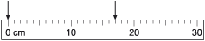
 | Answer a question by collecting, organising and interpreting data; use tally charts, frequency tables, pictograms and bar charts to represent results and illustrate observations; use ICT to create a simple bar chart  I can explain what a frequency chart tells me | You have to find out what sport your class prefers. Explain what you would do. How would you record the information?  Say three things that you can tell from this frequency table.  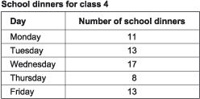  Why might so few children have chosen to have school dinner on Thursday?
 | Use Venn diagrams or Carroll diagrams to sort data and objects using more than one criterion  I can place objects on a Venn diagram | Where would you place these numbers on the diagram?  13, 20, 10, 7  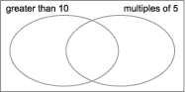  One of these shapes is in the wrong place on the diagram. Which one?  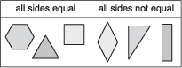
 | Use talk to organise roles and actions  I can discuss how to work together to solve a problem | You have to work as a group to measure each person's height, foot length and hand span. Start by deciding what each person will do.

…. Primary School Medium Term Plans

Year 3 Block C - Handling data and measures Unit 2
Date | Objectives | Assessment for learning | ICT Links
 | Follow a line of enquiry by deciding what information is important; make and use lists, tables and graphs to organise and interpret the information  I can decide what information to collect to answer a question | What are you trying to find out? What information will you collect? How?  How did you record your results? Why did you choose this sort of table/graph? What did it show?
 | - Know the relationships between kilometres and metres, metres and centimetres, kilograms and grams, litres and millilitres; choose and use appropriate units to estimate, measure and record measurements  I know that temperature can be measured in degrees Celsius | What measuring instruments would you choose to measure:  the distance around your head?  the temperature in the classroom?  the weight of an orange?  how much water a cup will hold?  Holly estimates that the temperature outside today is 1C. Do you think that this is a good estimate?  A bottle holds 2 litres of juice. How many millilitres is this?
 | - Read, to the nearest division and half-division, scales that are numbered or partially numbered; use the information to measure and draw to a suitable degree of accuracy  I can read the temperature on a thermometer to the nearest degree | What temperature does this thermometer show?  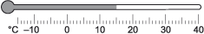  Choose a set of scales to weigh how heavy your shoe is to the nearest 100 g.
 | - Read the time on a 12-hour digital clock and to the nearest 5 minutes on an analogue clock; calculate time intervals and find start or end times for a given time interval  I can find how long a journey took if I know the start and end times | How would this time appear on a 12-hour digital clock?  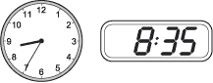  Kevin leaves home at quarter past 8 and arrives in school at 20 to 9. How long is his journey? How did you work this out?
 | - Answer a question by collecting, organising and interpreting data; use tally charts, frequency tables, pictograms and bar charts to represent results and illustrate observations; use ICT to create a simple bar chart  I can show information in a pictogram where each picture represents 2 people | You have to test the suggestion: We think most children in our class walk to school . What information will you collect? How?  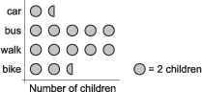  This pictogram shows how the children in a class came to school this morning.  How many children came to school by car? On foot? By bike? By bus?  Explain how to work out how many children there are in the class.  Did most of the class walk? How can you tell?
 | - Use Venn diagrams or Carroll diagrams to sort data and objects using more than one criterion  I can place objects on a Carroll diagram | Write each multiple of 5 up to 50 in the correct place on the diagram. What sorts of numbers are in the 'even' column?  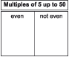  Is a cylinder a prism? Does it have any vertices? Where should it be placed on this Carroll diagram?  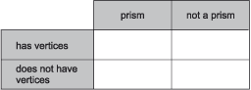
 | - Identify the presentational features used to communicate the main points  I can say what parts of a presentation helped me to understand | You have to tell the rest of your group which month contains most birthdays in the class and how you found out. Think of some important things you will say.  What did Henry say or do that helped you to understand?

…. Primary School Medium Term Plans

Year 3 Block C - Handling data and measures Unit 3
Date | Objectives | Assessment for learning | ICT Links
 | - Follow a line of enquiry by deciding what information is important; make and use lists, tables and graphs to organise and interpret the information  I can decide what information to collect to answer a question  I can choose how to show others what I have found out | What are you trying to find out? What information will you collect? How?  How did you record your results? Why did you choose this sort of table/graph? What did it show?  Did anything you found out surprise you?
 | - Describe and explain methods, choices and solutions to puzzles and problems, orally and in writing, using pictures and diagrams  I can explain how the class used information to solve a problem | You are going to make a poster to show another class how we decided which class race we chose for sports day. What will you write down? What diagrams or drawings will you use?
 | - Know the relationships between kilometres and metres, metres and centimetres, kilograms and grams, litres and millilitres; choose and use appropriate units to estimate, measure and record measurements  I can choose suitable units to estimate and measure length | Complete this table.  How many 10 cm strips could you cut from 1 metre of tape? How do you know?  Would you expect:  a door to be 1, 2 or 5 metres tall?  a hand span to be 5, 15 or 50 cm wide?  a teapot to hold 1 litre, 10 litres or 100 litres?
 | - Read, to the nearest division and half-division, scales that are numbered or partially numbered; use the information to measure and draw to a suitable degree of accuracy  I can read a scale to the nearest division or half-division | Draw a line that is 2 cm longer than this one [a line 5 cm long].  What measurement is shown on the scale?  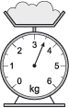
 | - Answer a question by collecting, organising and interpreting data; use tally charts, frequency tables, pictograms and bar charts to represent results and illustrate observations; use ICT to create a simple bar chart  I can show information in a tally chart or bar chart | Complete this tally chart.  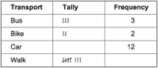  Look at this bar chart.  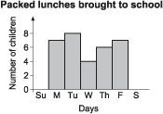  On which day were most packed lunches brought?  How many packed lunches were there in the whole week?  Why do you think that there are different numbers of packed lunches on different days?
 | - Explain a process or present information, ensuring items are clearly sequenced, relevant details are included and accounts ended effectively  I can explain how we found the information needed to solve a problem. I can explain each step in order | You have found out how the heights of everyone in the class changed between autumn and summer. Imagine you are explaining what you did to a visitor. What steps would you explain? Make sure they are in order. What would you end by saying?

